

**Enterprise Resource Planning Software as a Service Application**

**Requirement Specification**

**Group Members:**

Aldo Sula

Iris Rrucaj

Kledion Nito

**Accepted by:** Igli Hakrama

TABLE OF CONTENTS

1. EXECUTIVE SUMMARY 3
   1. PROJECT OVERVIEW 3
   2. PURPOSE AND SCOPE OF THIS SPECIFICATION 3
2. PRODUCT/SERVICE DESCRIPTION 3
   1. PRODUCT CONTEXT 3
   2. USER CHARACTERISTICS 3
   3. ASSUMPTIONS 4
   4. CONSTRAINTS 4
   5. DEPENDENCIES 4
3. REQUIREMENTS 5
   1. FUNCTIONAL REQUIREMENTS 5
   2. NON-FUNCTIONAL REQUIREMENTS 8
      1. Product Requirements 8
         1. User Interface Requirements 8
         2. Usability 9
         3. Efficiency 10
         4. Dependability Requirements 11
         5. Security Requirements 12
      2. Organizational Requirements 12
         1. Environmental Requirements 12
         2. Operational Requirements 12
      3. Domain Requirements 12
         1. Domain Requirements 12
4. SOFTWARE DESIGN 13
   1. User Scenarios 13
   2. Use Cases Extended 16
   3. Use Cases Diagrams 21
   4. Activity Diagrams 26
   5. Sequence Diagrams 34
   6. Collaboration Diagrams 43
   7. BPMN Diagrams 48
   8. Class Diagram 52
   9. Entity Relation Diagrams 56
   10. Object Diagrams 60
   11. State Diagrams 62
   12. Data Flow Diagrams 66
   13. Component Diagram 78
   14. Package Diagrams 81
   15. Deployment Diagram 82
5. DESIGN PATTERNS 83
   1. Design Patterns 83
6. **Executive Summary**

**1.1 Project Overview**

Keeping track of all business activities can be rather challenging, especially when there are multiple departments that require constant information transferring. In order to efficiently manage a fast-growing organization, a complete integrated system that covers all business aspects is more than necessary. “Business Notion” aims to effortlessly manage business operations in the sectors of financing, accounting, sales, marketing, and human resources. It empowers the individuals of different positions to increase productivity, to deliver better customer experience and provide full control over financial activities.

This solution is a SaaS (Software as a Service) application, meaning that all the information is stored and processed in the cloud, thus being flexible for growing businesses that are expanding in terms of data. The ability to process data remotely significantly decreases the costs and resources of generating results.

The software will enable its users to collect leads, close deals quickly, create quotes and invoices, track business expenses, run reports, save time by managing the working hours of your employees and pay them automatically.

* 1. **Purpose and Scope of this Specification**

The purpose of “Business Notion” is to assist managerial decisions and improve the overall company performance of PvEurosolution. This software will store customer and employee data and use them to make marketing automations in multiple channels, forecast outcomes such as: deal success rates, sales revenue on different time periods, customer engagement and satisfaction. The application will be used from almost every individual in the organization who uses, insets or benefits from business data. (Ex: CEO, sales manager, human resource manager, marketing analyst etc)

1. **Product/Service Description**

**2.1 Product Context**

“Business Notion” is a software which can be integrated in many departments; thus, each section of this application is dedicated to one department covering the most crucial functionalities. It categorizes the users depending on their position and information needs, meaning that an admin can have full control over the system where as a sales person can only use specific features.

**2.2 User Characteristics**

The following users are part of the system:

* System Administrator

Install, configure, customize, manage permissions, and access all the features in the application.

* Sales Manager

Access to product management, sales management, sales forecasting, and goal management.

* Salesperson

Access to everything from lead to invoice – lead, opportunities, quote, order, invoice. Create accounts and contacts, and track goals.

* Marketing manager

Access all customers personal information, manage prospect list, create marketing automation templates, access and make posts on social media channels, run multi-channel campaigns, view key marketing metrics

* Human resource manager

Access and modify employee data, make payroll automations, check working hours, approve leaves or absences, run employee performance reports

* 1. **Assumptions**
* It is assumed that every user that interacts with the system has the proper training, computer skills and professional knowledge to interact with the system and be able to user the features of it.
* It is assumed that every user has a smartphone or/and a computer with an internet connection due to the reason that the system based on an external server which can be accessed only through internet.
* It is assumed that every employee in the company has his/her own account created by the system admin
* It is assumed that sales data are gathered from the company’s website forms.
* It is assumed that the company has an active bank account which is used to pay the employees
* It is assumed that the company has at least 1 social media account used for marketing purposes
* It is assumed that the company has a list of prospects and clients which will be used for sales and marketing purposes
* It is assumed that the company has a template document for the quotes and invoices
* It is assumed that the company has email accounts for the employees on the following email providers: Google, Microsoft
* It is assumed that the company has a clear definition of each job title assigned to an employee
  1. **Constrains**
* The system can only be accessed through a stable internet connection.
* The system can only be integrated with a limited number of third-party applications
* The system is designed in different sections where each user which has access to the corresponding section should have prior knowledge or training to systems of this kind.
* The system does not allow the users to make customizations regarding the system main components in order to prevent anomalies.
  1. **Dependencies**
* The accountant should structure the type of report that the system should generate
* A quote cannot be created without a prospect and a minimum of 1 product/ service assigned to it
* An invoice cannot be created
* The response time is depended on the volume of requests and on the number of requests per user sent to the server
* An invoice cannot be created without a customer and a minimum of 1 product/ service assigned
* An email marketing campaign can only be initiated if there is at least one email account integrated to send the emails.
* A social media marketing campaign can only be initiated if there is at least one social media integrated and at least one post queued to be published.
* Prospects can only be imported to the marketing section if the excel file has the same template as the requested template of the system
* The price operational costs of the system are depended on the volume of the information and the resources needed to execute custom functionalities.

1. **Requirements**

**3.1 Functional requirements**

|  |  |  |  |  |  |
| --- | --- | --- | --- | --- | --- |
| Req# | Requirement | **Comments** | Priority | Date | SME Reviewed/Approved |
| BR_01 | The software should generate scheduled financial reports such as balance sheet, income report and cash flow. | This is a functionality included in the Finance & accounting section only the Accountant user, manager and system admin can access it | 1 | 19/04/22 | A. Sula  I. Rrucaj  K. Nito |
| BR_02 | The software should keep track of the working hours of the employees and automatically calculate their salary. | This functionality is included in the HR section and through an API the software will automatically calculate the wage and deposit the salary of the employees in their bank account | 1 | 19/04/22 | A. Sula  I. Rrucaj  K. Nito |
| BR_03 | The software should forecast the possibility of a lead to be converted into a deal based on different metrics entered in the program. | This functionality is included in the Sales section. With a machine learning algorithm called decision trees the program will classify and forecast sale performance and success deal rate | 4 | 19/04/22 | A. Sula  I. Rrucaj  K. Nito |
| BR_04 | The software should provide an easy to use interface where the employees can effortlessly create marketing campaigns. | Marketing campaigns are part of the marketing section | 1 | 19/04/22 | A. Sula  I. Rrucaj  K. Nito |
| BR_05 | The marketing automation tool should have a drag and drop interface | The drag and drop features include custom conditions such as: time duration, post delays, or triggers that can be initiated from different sections | 1 | 19/04/22 | A. Sula  I. Rrucaj  K. Nito |
| BR_06 | The marketing automation should be integrated with most of the social medias: Facebook, Instagram, Linkedin and it should also be integrated with most email providers |  | 1 | 19/04/22 | A. Sula  I. Rrucaj  K. Nito |
| BR_07 | Email campaign feature should let the user to enter in an excel or csv format the data of the prospects and also offer the possibility to enter the data manually on the application | The user should download a template in order for the excel file to get recognized by the system | 2 | 19/04/22 | A. Sula  I. Rrucaj  K. Nito |
| BR_08 | The email campaign should have A/B testing and email selection feature |  | 4 | 19/04/22 | A. Sula  I. Rrucaj  K. Nito |
| BR_09 | The email campaign should have a timing feature that allows the users to run the campaigns on scheduled basis |  | 2 | 19/04/22 | A. Sula  I. Rrucaj  K. Nito |
| BR_10 | The marketing section should display charts and dashboards related to email open & click rates, social media engagement, money spent on ads and the adds that are currently running | The marketing features should implement tracking methods for these statistics | 3 | 19/04/22 | A. Sula  I. Rrucaj  K. Nito |
| BR_11 | The marketing section should let the user automatically schedule social media posts | When a post is created the system should automatically place that post in the queue list | 2 | 19/04/22 | A. Sula  I. Rrucaj  K. Nito |
| BR_12 | The sales section should have these sub-sections: Lead( to save data about potential customers), contact/account( to save data about current clients), opportunity (save data about potential deals from actual customers) |  | 1 | 19/04/22 | A. Sula  I. Rrucaj  K. Nito |
| BR_13 | The lead subsection should display the name of the potential customer, email, phone number, VAT number (if its a business) |  | 1 | 19/04/22 | A. Sula  I. Rrucaj  K. Nito |
| BR_14 | The data account/contact subsection should be generated based on the data in the lead section so when a user decides that a lead has become a customer, he can automatically be transferred to the contact section | The data can also be entered manually | 2 | 19/04/22 | A. Sula  I. Rrucaj  K. Nito |
| BR_15 | The products/services category under the sales section should enable the user to create single products/ services or bundles |  | 2 | 19/04/22 | A. Sula  I. Rrucaj  K. Nito |
| BR_16 | The finance section should store data in table form and display useful charts which indicate useful business metrics that can be used to determine business performance | These charts and dashboards can be modified and created by the user | 1 | 19/04/22 | A. Sula  I. Rrucaj  K. Nito |
| BR_17 | In the finance section the accountant should connect to the business taxation system and periodically generate automatic reports and send them to the desired destination | This can be possible only if there is a webhook that can get the date from the system | 3 | 19/04/22 | A. Sula  I. Rrucaj  K. Nito |
| BR_18 | The HR section should save the data of the employees in the company and display them in table form |  | 1 | 19/04/22 | A. Sula  I. Rrucaj  K. Nito |
| BR_19 | The HR users should be able to add new employee data, modify and delete existing ones | Employees will have a limited access to the system | 1 | 19/04/22 | A. Sula  I. Rrucaj  K. Nito |
| BR_20 | The employees should have an easy interface to add working hours |  | 1 | 19/04/22 | A. Sula  I. Rrucaj  K. Nito |
| BR_21 | The software should automatically generate HR reports which indicate employee performance which then can be used to predict overall business performance | The reports can be customized by the user | 3 | 19/04/22 | A. Sula  I. Rrucaj  K. Nito |
| BR_22 | The sales person should be able to generate quotes and add products to them while integrating it with the contact data | The quote should have a template inserted before the creation of a quote | 1 | 19/04/22 | A. Sula  I. Rrucaj  K. Nito |
| BR_23 | The sales person should be able to convert an existing quote to an invoice and add or remove products, or modify the price of them |  | 1 | 19/04/22 | A. Sula  I. Rrucaj  K. Nito |
| BR_24 | The system administrators are the only users which can create modify and delete other users | The system admins can also assign this permission to other users | 1 | 19/04/22 | A. Sula  I. Rrucaj  K. Nito |
| BR_25 | The software should have a multiple user access. Each user can have one or more privileges depending on their actual role |  | 1 | 19/04/22 | A. Sula  I. Rrucaj  K. Nito |
| BR_26 | The system administrator should be able to access all the sections in the system and modify specific graphics |  | 1 | 19/04/22 | A. Sula  I. Rrucaj  K. Nito |
| BR_27 | The CEO should have a section on his own where he can see all the reports, dashboards and key metrics from all the sections | This feature can be in a form of a periodic report sent to the CEO’s email address | 4 | 19/04/22 | A. Sula  I. Rrucaj  K. Nito |
| BR_28 | The CEO should also have a notification feature which notifies him on key department activities such as closed deals, starting of marketing campaigns, different transactions | The notification feature should be chosen by the CEO (through email, slack, Microsoft teams etc) | 2 | 19/04/22 | A. Sula  I. Rrucaj  K. Nito |
| BR_29 | The software should be scalable and should be accustomed depending on the data intensity | This can be possible with cloud computing by AWS | 1 | 19/04/22 | A. Sula  I. Rrucaj  K. Nito |

**3.2 Non-Functional requirements**

**3.2.1 Product Requirements**

**3.2.1.1 User Interface requirements**

* The system will be a web-based application; thus, it can be accessed by the following browsers: Chrome, Mozilla Firefox, Safari, Microsoft Edge.
* As mentioned previously the users will need a prior knowledge to ERP systems and each user should have sufficient knowledge in their profession in order to completely understand the procedures of the system.
* The system should have 4 main sections where each section is dedicated to a specific type of users which have similar professional skills.
* The system’s main sections are: Sales section, Marketing section, Account& Finance section, Human Resource section
* Each section should in the form of a navigation bar where the user click on the hamburger menu and the 4 main sections are displayed.
* On the right side of the interface the functionalities of each section currently active should be displayed in categories.
* The sales section will have the categories Contacts: which have as features the account and customer management. The second category is Collateral which has as features quote, order, and invoice management
* The marketing section will have the category Email marketing with features Create campaign, upload prospects, edit email marketing automation. The second category will be: Social Media scheduler with features such as: create post, manage campaign, manage/integrate channels.
* The accounting section will have two types of interfaces: one if for the employees, where the only features available are the salary check, leave request form, attendance/work hour submission. The second interface can be accessed by the HR team where the features included are: payroll for the employees, report generation, report structure builder, performance monitoring
* The administrator of the system will have access to all the dedicated interfaces and also, he/she can make limited customizations to the necessary features.
* The system administrator is the only user who can give access permissions to all the other users, so the only way of accessing the system is through a log in where it will require the email and password.
* The social media automation feature will have a drag and drop feature where the user will connect each component (post, channel) with various conditions (time conditions, sales conditions, target audience conditions) in the form of a diagram builder.
* The work hour report will be a simple interface for the employees where the date will be automatically chosen the only interaction is the clock in, clock out and “have a break” button.
* The report structure generator feature will have a similar drag and drop feature where the accountant can arrange each field data in a sheet and when a report request is initiated, the field data will be automatically filled based on the data binding done by the accountant.
* The prospect, customer and account creation interface will have a similar design. The specified user will add the details of these entities in the field forms where each field will be grouped based on the relevance or connections between these fields. For example: the fields conserving the address of the contact will be grouped in a section called contact address information.

**3.2.1.2 Usability**

**Accessibility**  
The system will be accessed only is the system administrator has created an account for him/her and if the user has a stable internet connection.

**Responsiveness**

The system will be desktop and mobile friendly as there are scenarios where users need to access their profile, or features through a different device. The system will have a complex architecture regarding the uptime of the service. Mainly this architecture will create similar replicas of the system settings so when a replica is down, a load balancer redirects the request to the other one with the same port and IP address.

**Flexibility**

* The system will have a dynamic flexibility meaning that depending on the request volume it will automatically allocate memory and resources to support these requests.
* Effectiveness
* The system has almost every feature automated, thus leading to less human errors while creating complex processes such as customer journeys, marketing automations and payrolls.
* Training videos on how to use the system properly will be provided to the specified users based on their access on the system.
* For every unexpected behavior of the system there will be easy to understand and self-explanatory error messages.

**Efficiency**

* With the use of drag and drop features almost every individual can accomplish the main operations of the system, thus leading to a more efficient workflow.
* The navigation interface between sections will be based on the most popular software, in order for the users to have a small curve of learning the navigation process.
* The interaction with the features will be straight forward and without many steps to operate it.

**3.2.1.3 Efficiency**

**3.2.1.3.1 Performance requirements**

* The performance of the software will be highly depended on the subscription tier that the company will choose, as more resources needed will higher the costs of operating. The network connection is also a constrain in the performance of the system due to the fact that the bandwidth of the network connection of the user should match the bandwidth of the server.
* The system will stay consistent in its performance with the help of could computing. Where a service will have default parameters which will determine if the performance is satisfactory or not and it will allocate more resources when needed to keep the performance metrics stable.
* The same concept can be applied with the storage of the data. If the volume of data is increasing, depending on the subscription, the system will request more storage capacity to the cloud storage provider.
* The system is mostly server-side-based, meaning that most of the processes are operated by the server rather that the device of the user, thus the users do not need powerful devices to use the system

**3.1.2.3.2 Space requirements**

* The expected number of users which can use the system simultaneously without any performance drop is maximum 400 users with the most expensive subscription tier.
* Recommended device requirements:
* For PC and laptops:
* CPU → 2GHz Dual Core
* User device memory: 4GB RAM, 100 GB HDD or SSD
* Ethernet connection speed: 30 Mbps

**3.2.1.4 Dependability Requirements**

**Availability**

* The system should be available 24/7 and without any performance drop during the working hours.
* The system should be available at any geographical position.
* The system should be available at any device that has a browser installed.
* The system should be available only if the device which will access it will have an internet connection

**Reliability**

The system will have a cloud service which will regulate the necessary resources to operate in the expected performance.

**Monitoring**

Through the cloud computing platform, the system will be monitored for every GET/POST request and it will provide necessary data about the destination of the request, the return value of the request and it will detect if there is any anomaly in the request body.

The platform of managing the system will monitor and take automatically necessary actions regarding the load balance of the system as well as making regular backups without interrupting the service.

**Maintenance**

The system will have a self-reporting feature that will notify the development team for any bug that the user might encounter. This feature will include data about the request body, the events or actions that the user made that led to this bug exploitation and other time/performance details.

**Integrity**

Every credential created by the system admin will be integrated into a secret environment where no user or developer can access.

Each manager on each section depending on the privileges that he/she has, can add new lower-level users to the system only if the user is in the same department.

Each user should provide their created credentials such as: email, password in order to get access to the system features and their profile.

**3.2.1.5 Security Requirements**

When a new user is registered by the admin, a one-time access token will be sent to the user’s email. Through this token the user will get redirected to enter his/her password and to enable the two-factor authentication method.

The database can be accessed only by the admin of the system and the users assigned with the necessary database access privileges.

The system admin would have the option to allow only specific devices to access the system, thus blocking every request coming from an unknown device which is not part of the organization.

The personal information of each user, employee, prospect, customer and account will not be gathered for any kind of purpose from the developers. Only bug reporting data will be available to be sent to the development team of the system for further improvements.

**3.2.2 Organizational Requirements**

**3.2.2.1. Environmental Requirements**

The system will be cloud based and demand based so every resource allocated will be used to its full extend without wasting computing power and reserving more space than necessary. The system in this way is being efficient and saving computing power which means less energy wasted.

**3.2.2.2 Operational Requirements**

The system will combine intelligence from different departments thus enabling better communication and coordination between employees from different departments. When the data is converted from one section to another the scope of these data changes in order for the users to spent less time managing and rearranging the required information.

* 1. **Domain Requirements**

The system is a web-based application that provides multiple type of users mostly depending on the feature access privileges.

Sales users can access only the sales section of the system, where sales manager can approve quotes, invoices and close opportunities.

Marketing users can access only the marketing section where content creators can create posts and build marketing campaigns and marketing managers who approve the initiation of the campaigns, schedule the posts, initiate email deliveries etc.

Finance users can access only the finance section features and data, accountants can add new financial data, request data from other departments, construct reports and generate reports based on organizational needs.

HR users are split into two types. The hr managers can approve leaves, manage work hours, pay the employees etc. The second type of employees can only submit they leave request and turn in their shifts.

1. **Software Designs**

**4.1 User Scenarios**

Scenario title: User logs in the system

1. User opens browser
2. Writes the link of the website
3. Clicks on the login button
4. Writes the credentials
5. The system recognizes the credentials and sends a verification message to the users email address
6. The user checks the email
7. Writes the code
8. User gains access the system

Scenario title: User logs in the system with wrong credentials

1. User opens browser
2. Writes the link of the website
3. Clicks on the login button
4. Writes the credentials
5. The system checks that a user with these credentials does not exist
6. The system prompts the user to contact the admin in order to create an account

Scenario title: A customer calls about building a solar system

1. Create a new contact record on the Sales Contacts form
2. Sales rep fills out the data of the prospect
3. The system verifies the data if there are duplicate with other entities
4. The sales rep saves the data
5. The system sent the data to the database
6. The system lists all the customers in the Customer view section

Scenario title: A new website form submission has been received

1. Sales rep gathers the data from the form submission
2. Sales rep opens the prospect form
3. Sales rep imports the form data in excel file
4. Sales rep creates prospect
5. Prospect saved in the database
6. Sales rep creates an opportunity
7. Sales rep attaches a quote to the opportunity and adds the products
8. The system sends the quote to the email provided in the form

Scenario title: One of the potential customers is not more interested

1. Sales rep opens the opportunity section
2. Reviews the reasons of the opportunity lost
3. Documents the customer journey
4. Marks the opportunity as lost
5. Notifies team members and supervisors
6. Transfers the prospect to the marketing prospects

Scenario title: An opportunity has a high probability of success

1. Sales rep opens the profile of the opportunity
2. Reviews the data and customer journey
3. Converts the quote to an invoice
4. Reviews the products in the invoice
5. Sales rep adds a discount to the total amount
6. Sales rep sends the invoice through the system
7. The system queues the request
8. The system sends the invoice to the given email address
9. The system calculate and marks the opportunity probably

Scenario title: marketing manager initiatives an email campaign

* The manager goes to the marketing section and clicks on the email marketing category
* The manager clicks on the create campaign button
* The manager fills the campaign details
* The manager chooses the sender email
* The connection with the sender email provider is successful
* The manager chooses A/B testing feature
* The manager adds the subject for both samples
* The manager adds the email body
* The manager includes the link tracking feature
* The manager imports through an excel file the prospect details
* The system validates the prospect details
* Validation successful
* The system stores the new data in the database and updates the existing ones
* The manager sets the email daily volume, email delivery timeframe and the delivery days.
* The campaign is verified by the system
* Campaign successfully started

Scenario title: marketing manager creates a new social media campaign

1. The manager clicks on the marketing section and navigates to the social media scheduler
2. The manager clicks on the create social media campaign
3. The manager fills out the campaign details
4. The manager requests from the content creator the post details, images and tags
5. The manager verifies the posting schedule plan proposed by the content creator
6. The manager approves the schedule
7. The system builds the schedule structure
8. The manager adds the posts in the scheduler
9. The system verifies the image format and other SEO details
10. The system stores the action in the database
11. The system initiates the campaign

Scenario title: A new email format should be implemented in an existing email campaign

1. The manager gets access to the campaign list
2. Chooses the email that will be revised
3. The system stops sending emails
4. The system displays the campaign editor
5. The manager updates the email subject and body
6. The system restarts the campaign where it was left

Scenario title: An employee clocks in and out for his shift

1. Employee logs in the system
2. Employee goes to the shift section
3. Employee clicks on the clock in button
4. The system starts the timer
5. Employee clocks out when the shift ends
6. The system marks the attendance and the work hours
7. The system updates the current employee salary
8. The system lists in the hr manager’s section the attendance and work hour details

Scenario title: CEO requests an employee performance report

1. HR manager goes to the report generation under the hr section
2. HR manager gets notified about the request
3. HR manager reviews the request
4. HR manager checks if the requested report has a template in the system
5. HR manager chooses the report
6. HR manager sends the file to the CEO
7. CEO gets notified about the arrival of the email with the report

Scenario title: CEO requests an financial report

1. Accountant goes to the report generation under the hr section
2. Accountant gets notified about the request
3. Accountant reviews the request
4. Accountant checks if the requested report has a template in the system
5. Accountant chooses the report
6. Accountant sends the file to the CEO
7. CEO gets notified about the arrival of the email with the report

Scenario title: Accountant builds a report template

1. Accountant goes tot the report generation section under the hr section
2. Accountant clicks on the create report template
3. The system displays the report builder
4. Accountant drag and drops the fields that the report will show
5. Accountant adds the report details
6. Accountant creates the report template and reviews it by seeing some samples

Scenario title: System admin creates a new account

1. The admin goes to the admin section and adds the email of the employee that will have access in the system
2. The admin chooses the permissions of the user
3. The admin clicks on the create button
4. The system sends email with token access to the email entered by the admin
5. The user receives the token access and creates his account password

**4.2 Use cases**

|  |  |
| --- | --- |
| Usecase 1.1 | Login User |
| Scope: | ERP integrated System |
| Level: | User Level |
| Intention Context: | Users with different privileges assigned by the admin should access the system |
| Minimum Guarantees: | User has entered the credentials correctly, but the server is overloaded |
| Success Guarantees: | User has entered the credentials correctly and is able to use the software |
| Primary Actor: | All users |
| Stakeholder’s interest: | To have all intended users able to login into the system |
| Precondition: | The individual has the necessary credentials given by the system administrator |

|  |  |
| --- | --- |
| Usecase 1.2 | Create Lead |
| Scope: | ERP integrated System |
| Level: | User Level |
| Intention Context: | Any sales person can generate a lead entity in the system |
| Minimum Guarantees: | Lead is created in the database but is not loaded in the table |
| Success Guarantees: | Lead is created and displayed in the table |
| Primary Actor: | Sales Person |
| Stakeholder’s interest: | To have the sales person store leads for further analysis |
| Precondition: | The sales person should have useful data about the lead |

|  |  |
| --- | --- |
| Usecase 1.3 | Create Account/ Contact |
| Scope: | ERP integrated System |
| Level: | User Level |
| Intention Context: | Sales person can store account data in the system |
| Minimum Guarantees: | Data is stored but some key fields are not filled |
| Success Guarantees: | All necessary data for further analysis are entered |
| Primary Actor: | Sales Person |
| Stakeholder’s interest: | To have a list of all the accounts and contacts that the company is working with. |
| Precondition: | The account should be also labeled into one lead and it should contain all the necessary information |

|  |  |
| --- | --- |
| Usecase 1.4 | Create opportunity |
| Scope: | ERP integrated System |
| Level: | User Level |
| Intention Context: | Sales person can create a deal opportunity based on an account created |
| Minimum Guarantees: | No additional data about the account is added |
| Success Guarantees: | Additional data received from the contact is added to the opportunity entity |
| Primary Actor: | Sales Person |
| Stakeholder’s interest: | To have a detailed description of the communication with the potential customer |
| Precondition: | An account/contact should be assigned to an opportunity |

|  |  |
| --- | --- |
| Usecase 1.5 | Generate Quote |
| Scope: | ERP integrated System |
| Level: | User Level |
| Intention Context: | Sales person can create a quote based on the contact and product data |
| Minimum Guarantees: | Quote is created but no customer data is attached |
| Success Guarantees: | Quote is created with all the necessary data and is emailed to the customer |
| Primary Actor: | Sales Person |
| Stakeholder’s interest: | To effortlessly send quotes to specified customer and keep track of all the quotes |
| Precondition: | The software should have fully specified products/ service |

|  |  |
| --- | --- |
| Usecase 1.6 | Generate Invoice |
| Scope: | ERP integrated System |
| Level: | User Level |
| Intention Context: | Salesperson can convert a quote to an invoice and can modify the data of the invoice based on the quote data |
| Minimum Guarantees: | Invoice is created but it is not derived from a quote |
| Success Guarantees: | An invoice derived from the quote is created and sent via email to the customer |
| Primary Actor: | Sales Person |
| Stakeholder’s interest: | To effortlessly convert a quote to an invoice and sent it to the specified customer |
| Precondition: | The software should have fully specified products/ service |

|  |  |
| --- | --- |
| Usecase 1.7 | Close Deal |
| Scope: | ERP integrated System |
| Level: | User Level |
| Intention Context: | Salesperson can close a deal when every aspect of the sale is completed. The deal can be won or lost. |
| Minimum Guarantees: | Deal is created but its still pending for a result |
| Success Guarantees: | Deal is won |
| Primary Actor: | Sales Person |
| Stakeholder’s interest: | To manage deals and gather as much data as possible for forecast and analysis |
| Precondition: | At least a product and an invoice should be attached to the deal entity |

|  |  |
| --- | --- |
| Usecase 1.8 | Forecast Sales |
| Scope: | ERP integrated System |
| Level: | System Level |
| Intention Context: | The software should predict the future sales profits based on data inserted |
| Minimum Guarantees: | The software is in training mode and its is learning from the data inserted |
| Success Guarantees: | The software is making accurate predictions |
| Primary Actor: | Admin |
| Stakeholder’s interest: | To accurately predict sales and enable faster decision making |
| Precondition: | The software should have a large amount of data in order to |

|  |  |
| --- | --- |
| Usecase 1.9 | Generate Invoice |
| Scope: | ERP integrated System |
| Level: | User Level |
| Intention Context: | Salesperson can generate sales reports and automatically send them to the CEO section where all the key metrics are showed |
| Minimum Guarantees: | Report is created but not sent to the CEO as it is pending |
| Success Guarantees: | Report is created and the data is updated in the CEO secton |
| Primary Actor: | Sales Person |
| Stakeholder’s interest: | To update business data regarding sales as fast as possible |
| Precondition: | Multiple deals, leads, opportunities, contacts need to be created |

**4.3 Use case diagrams**

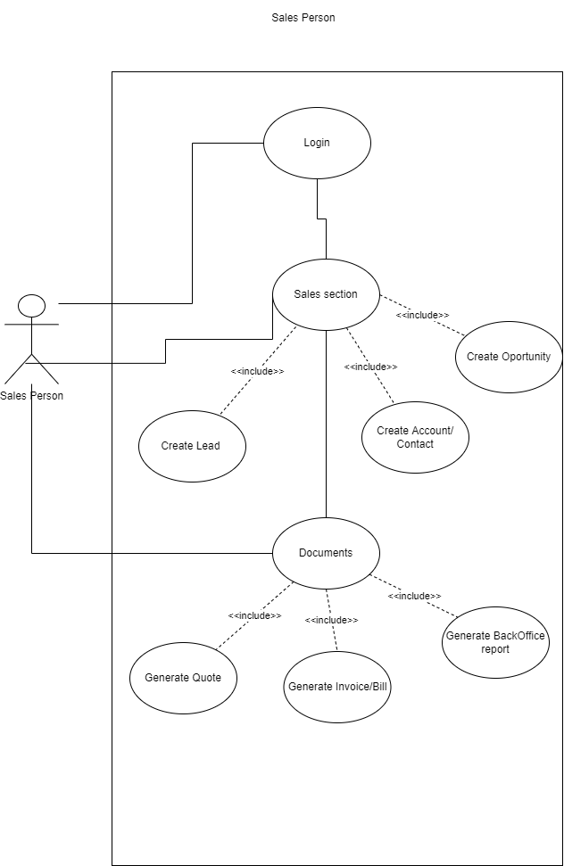Sales section use case diagram

Human resource section user case diagram

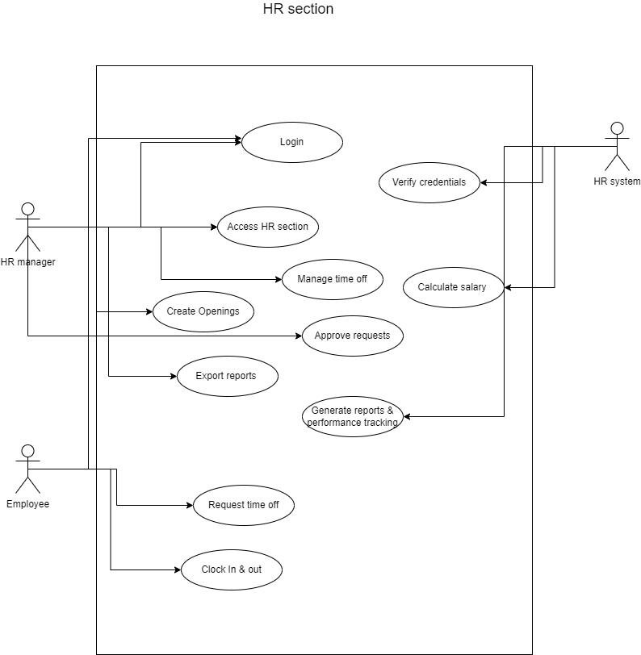

Marketing section user case diagram

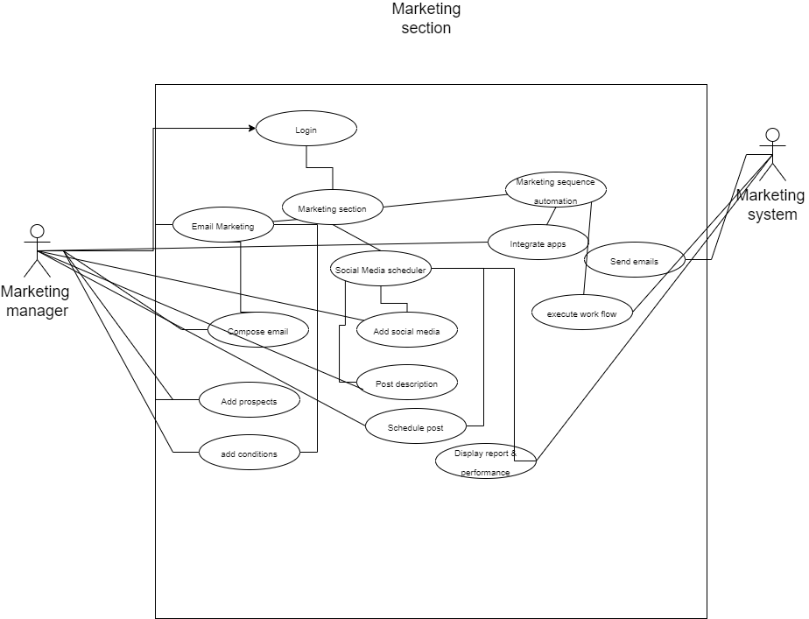

Finance management user case diagram

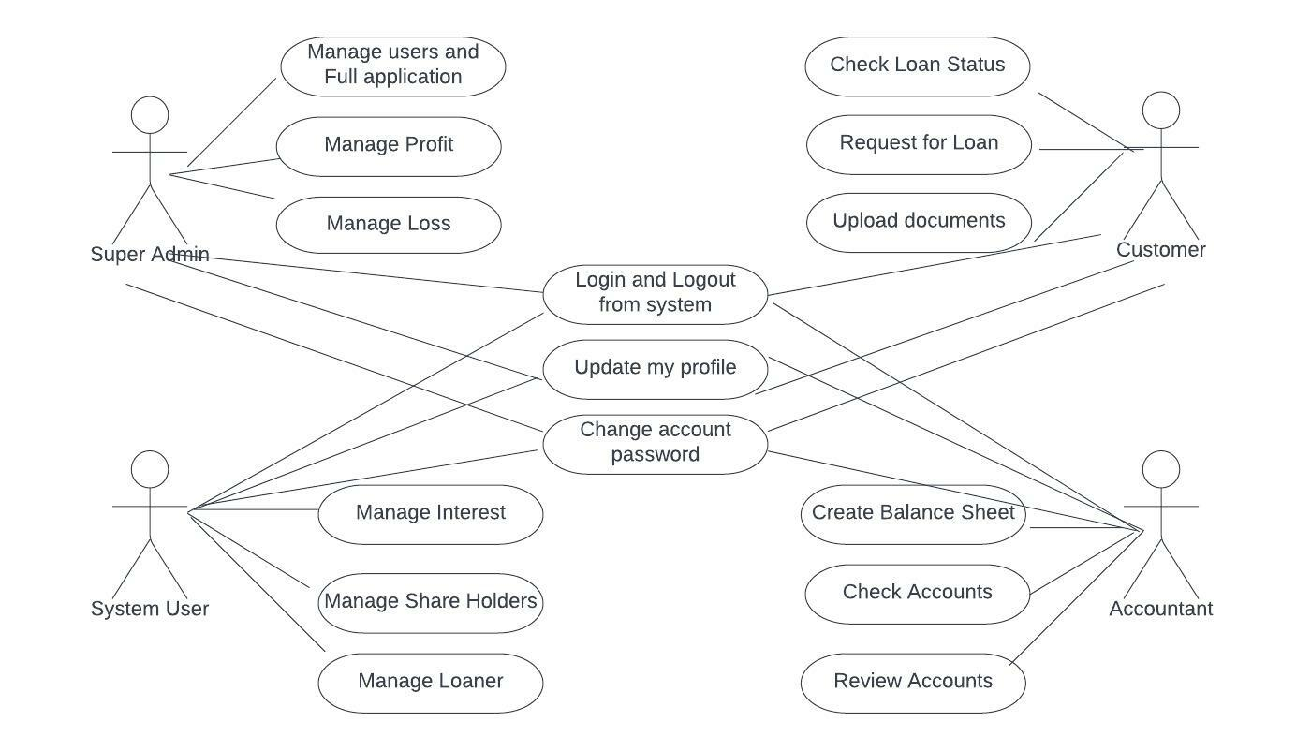

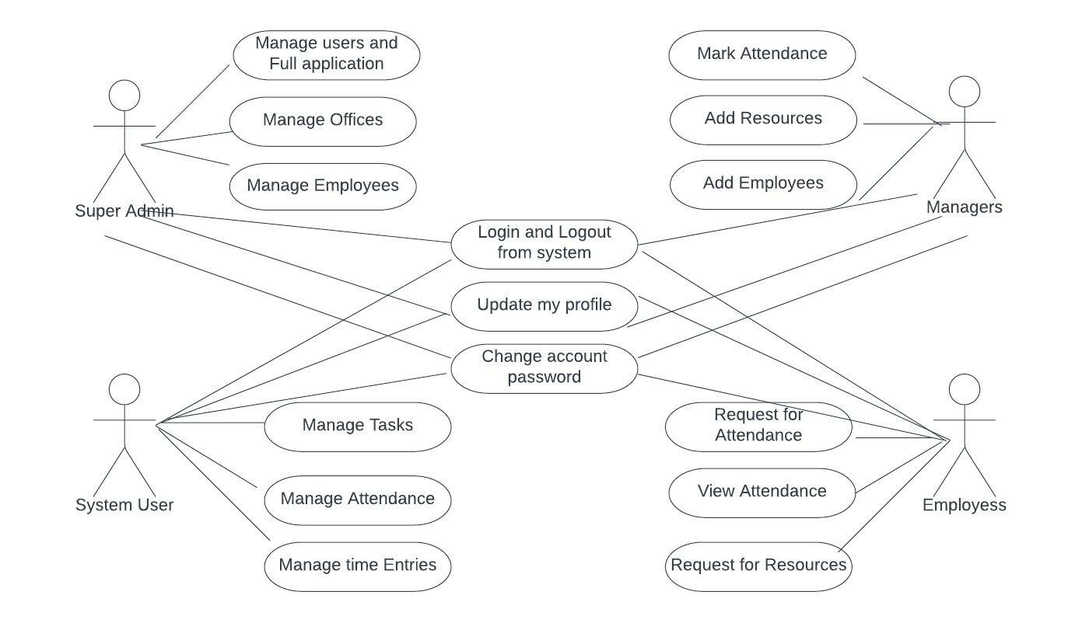Office management user case diagram

Human resource management user case diagram

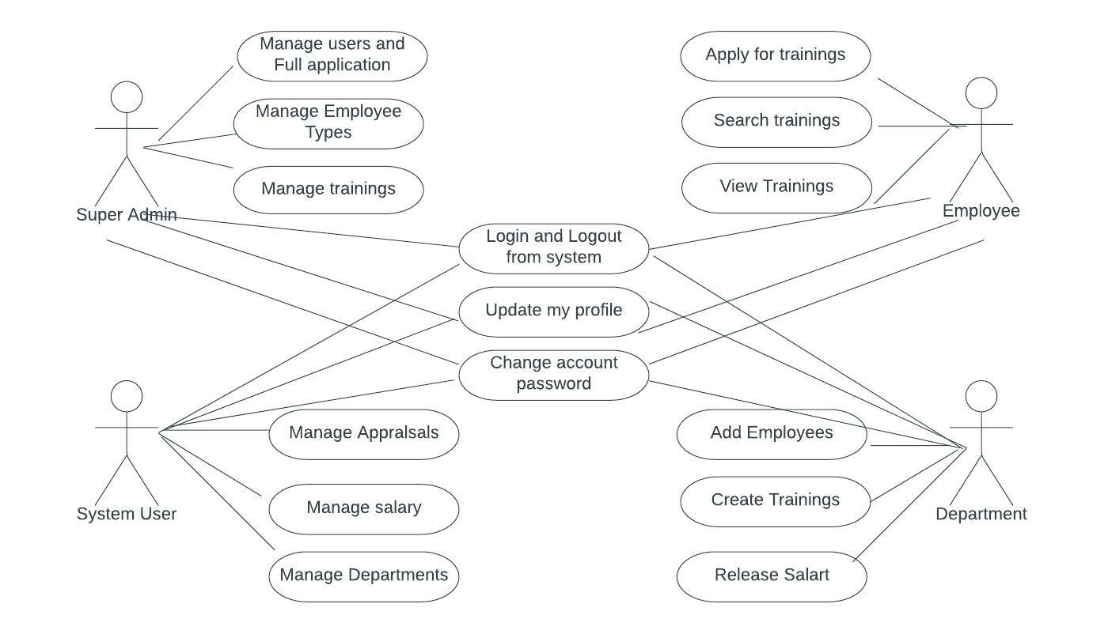

**4.4 Activity Diagrams**

Activity diagram log in to the system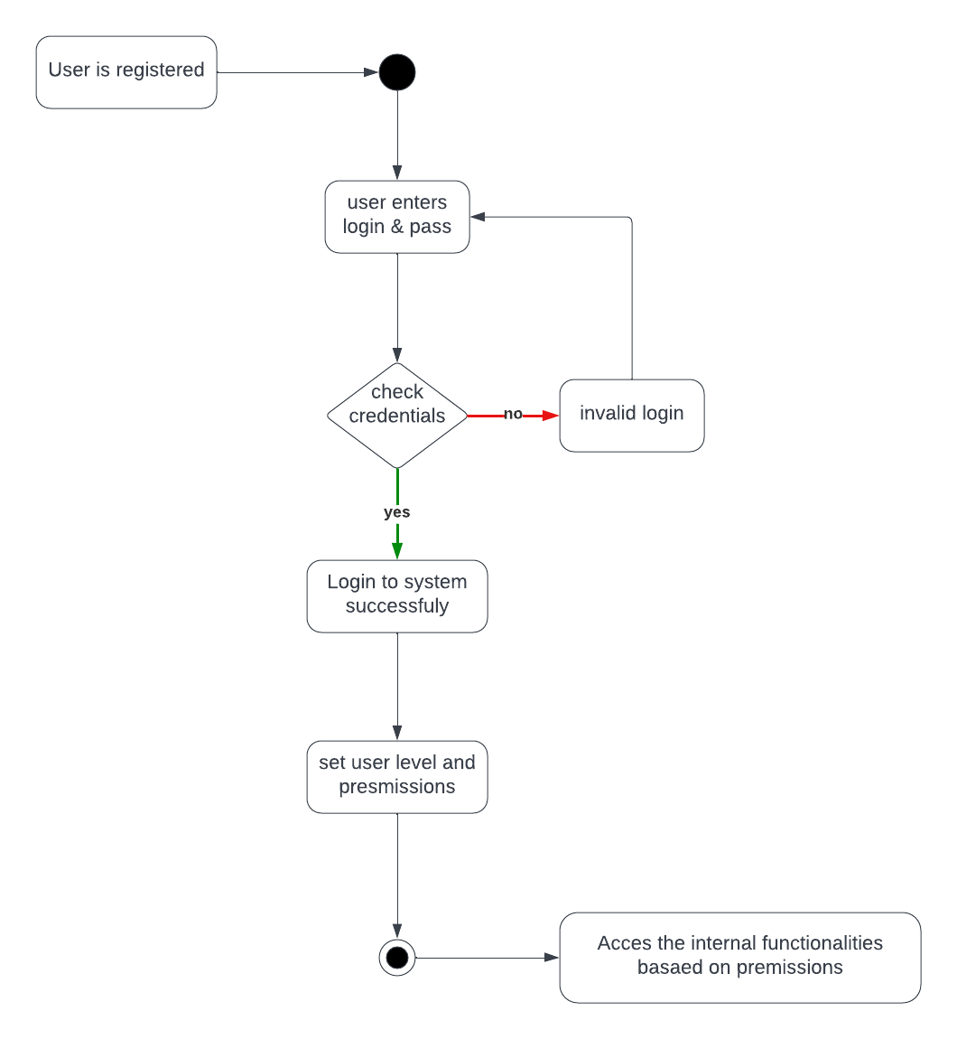

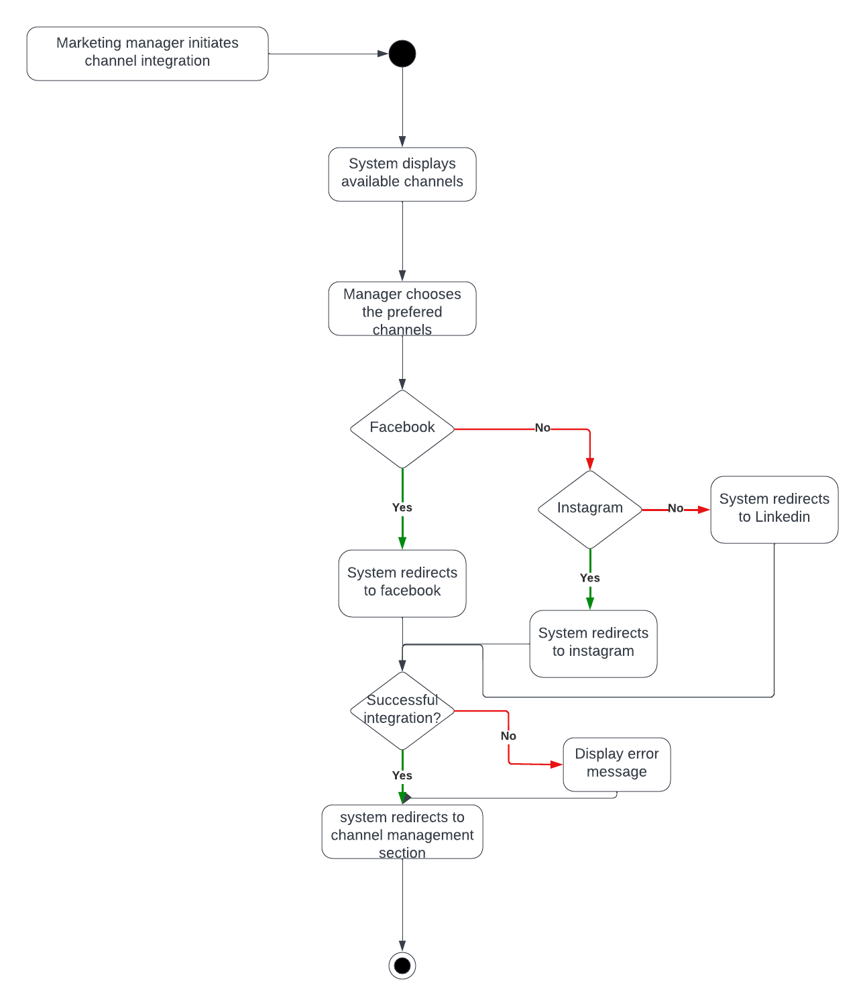Activity diagram social media channel integration

Activity diagram employee request leave

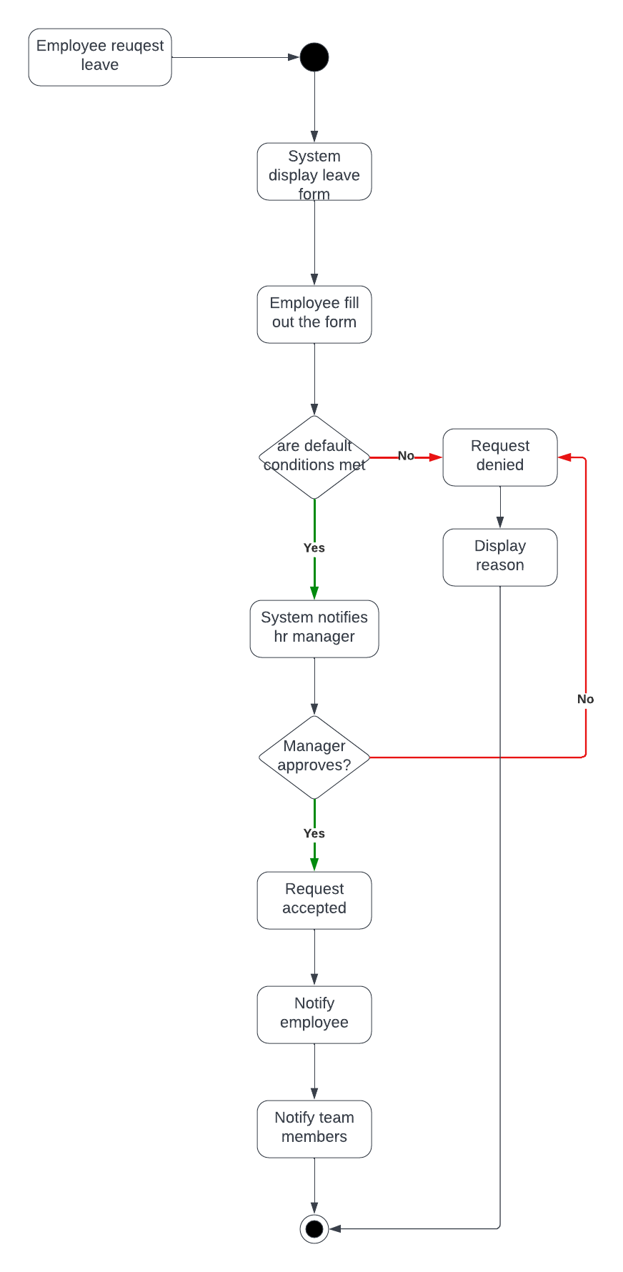

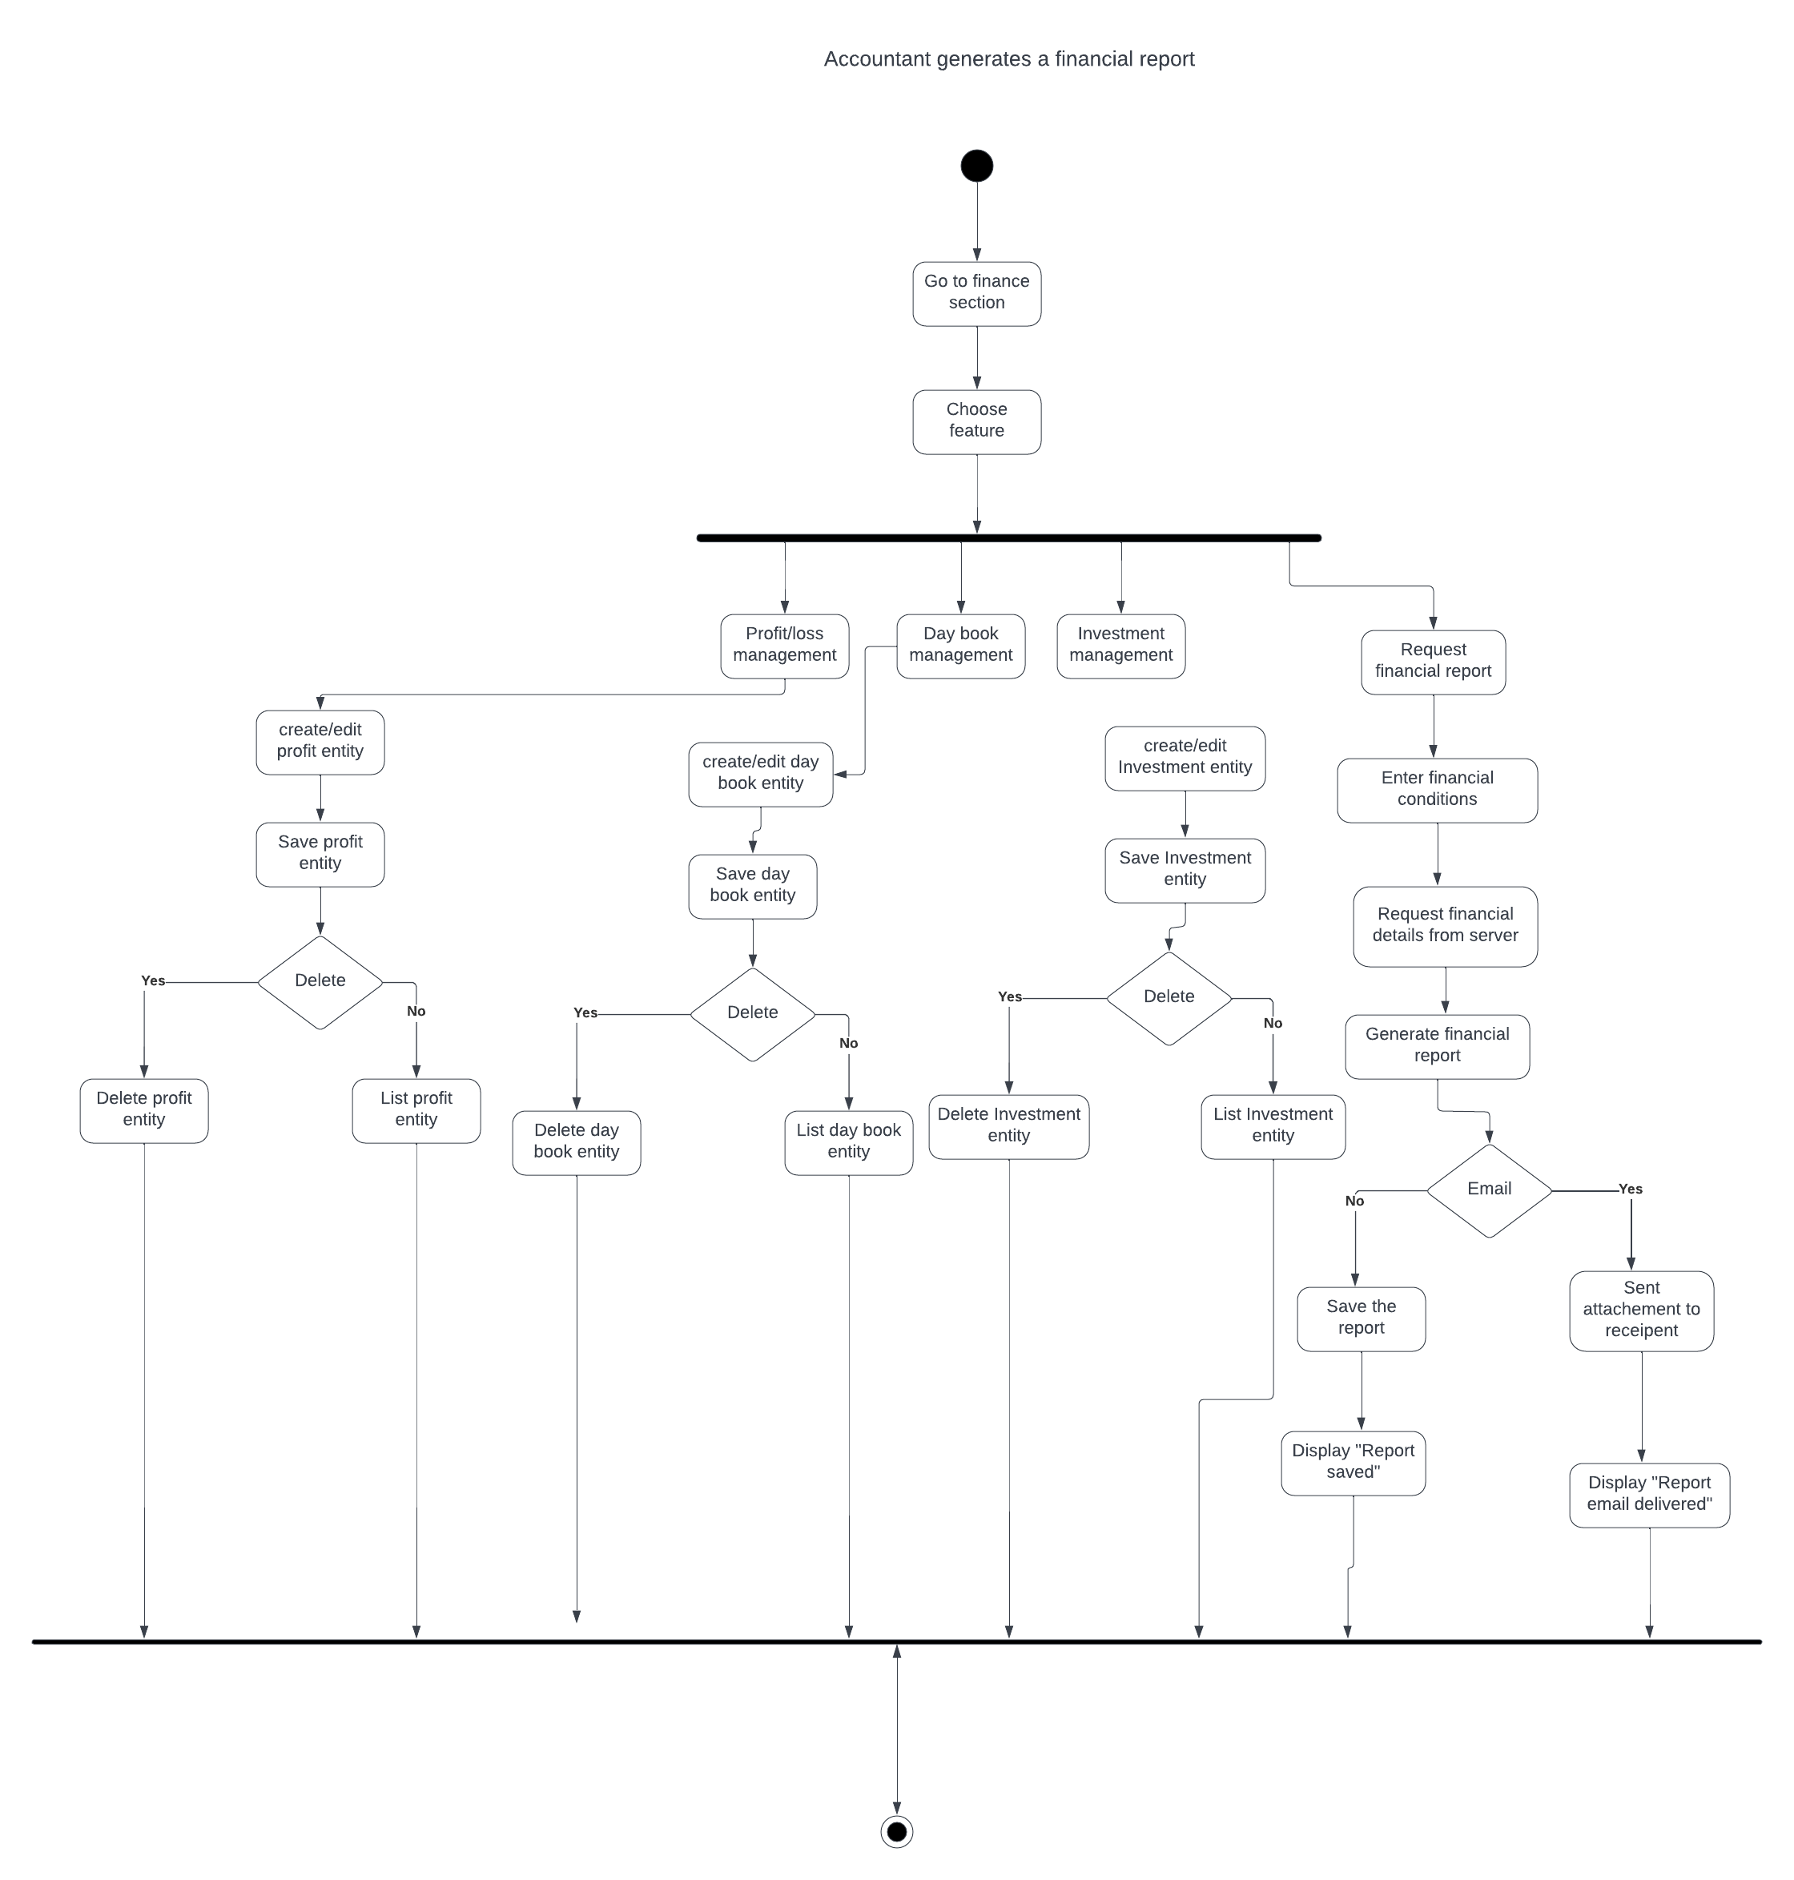Activity diagram financial data and reporting

Activity diagram marketing automation

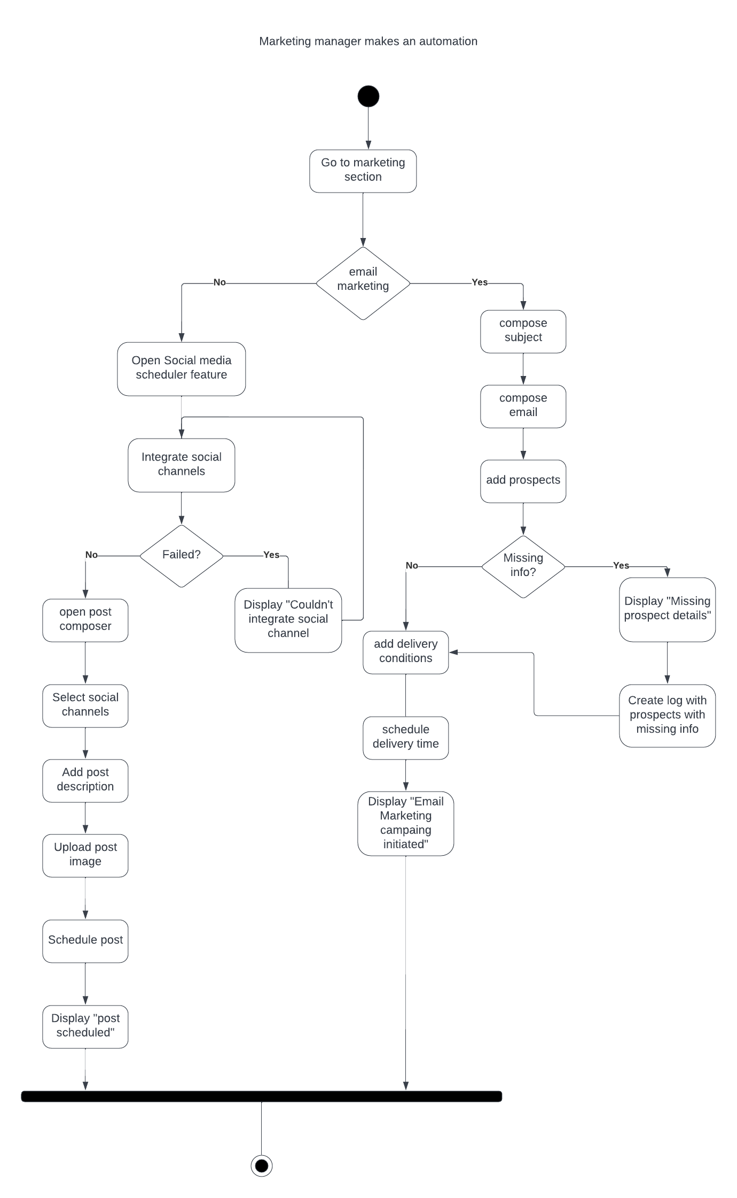

Activity diagram marketing prospect insertion

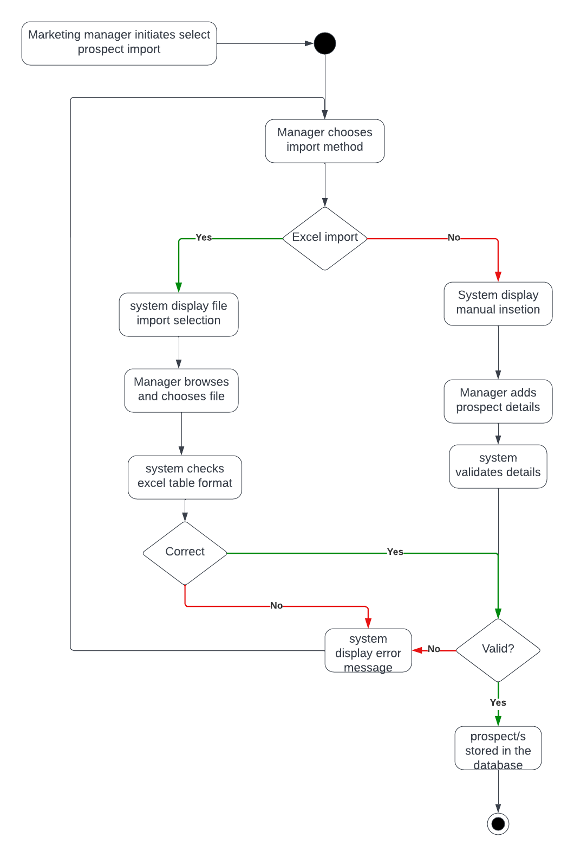

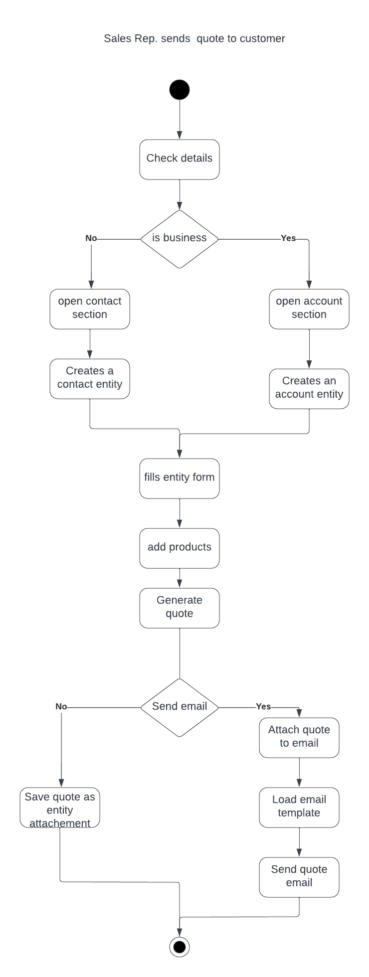Activity diagram quote delivery

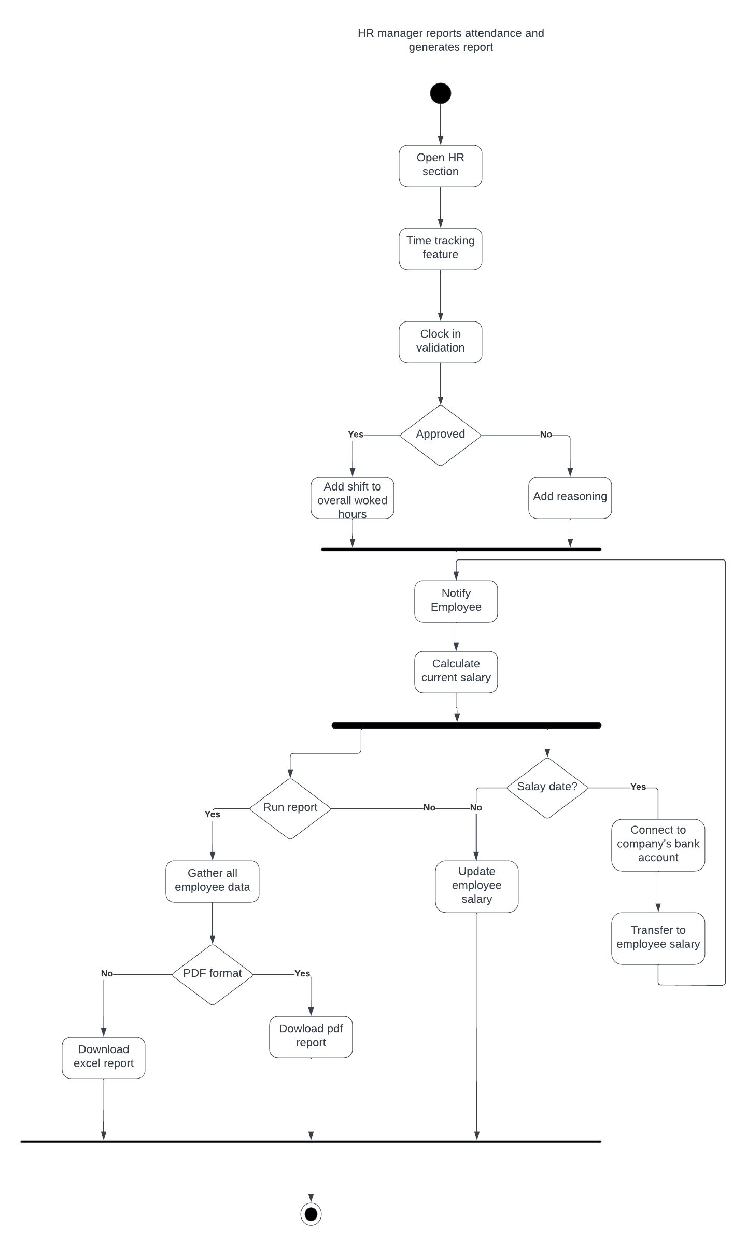Activity diagram attendance report generation

**4.5 Sequence diagrams**

Sequence diagram login to system

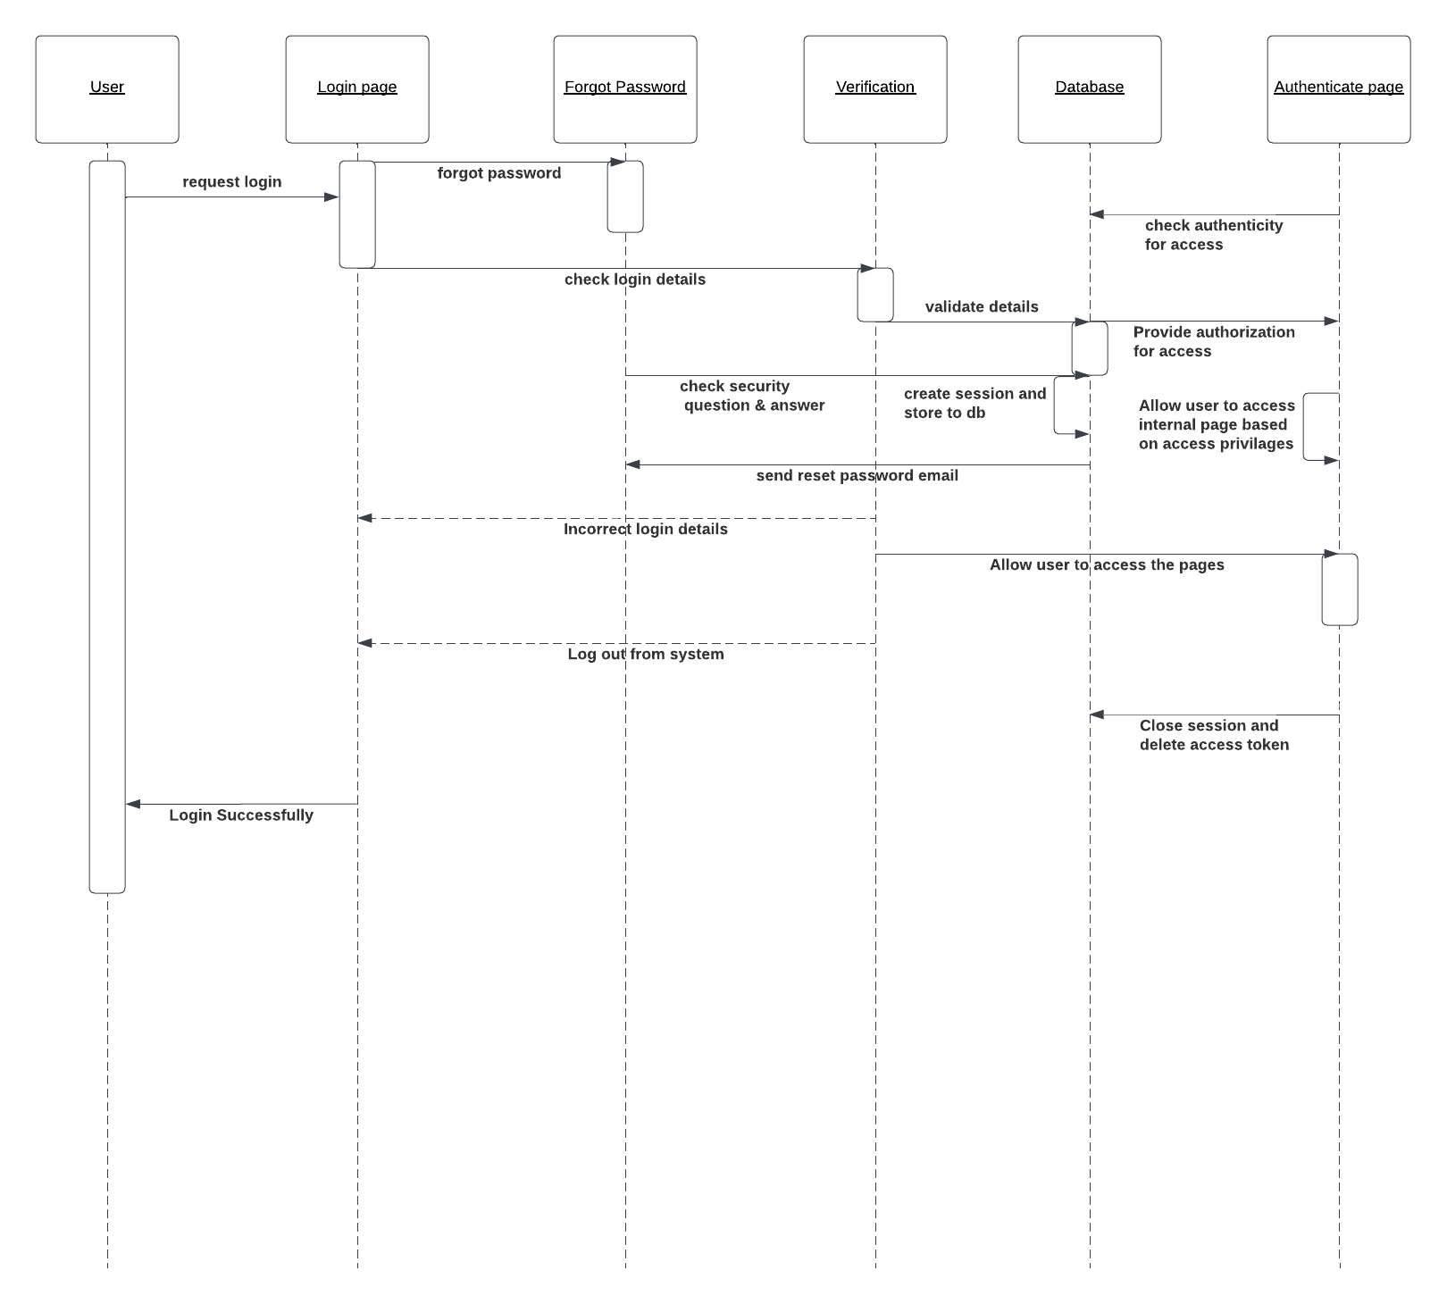

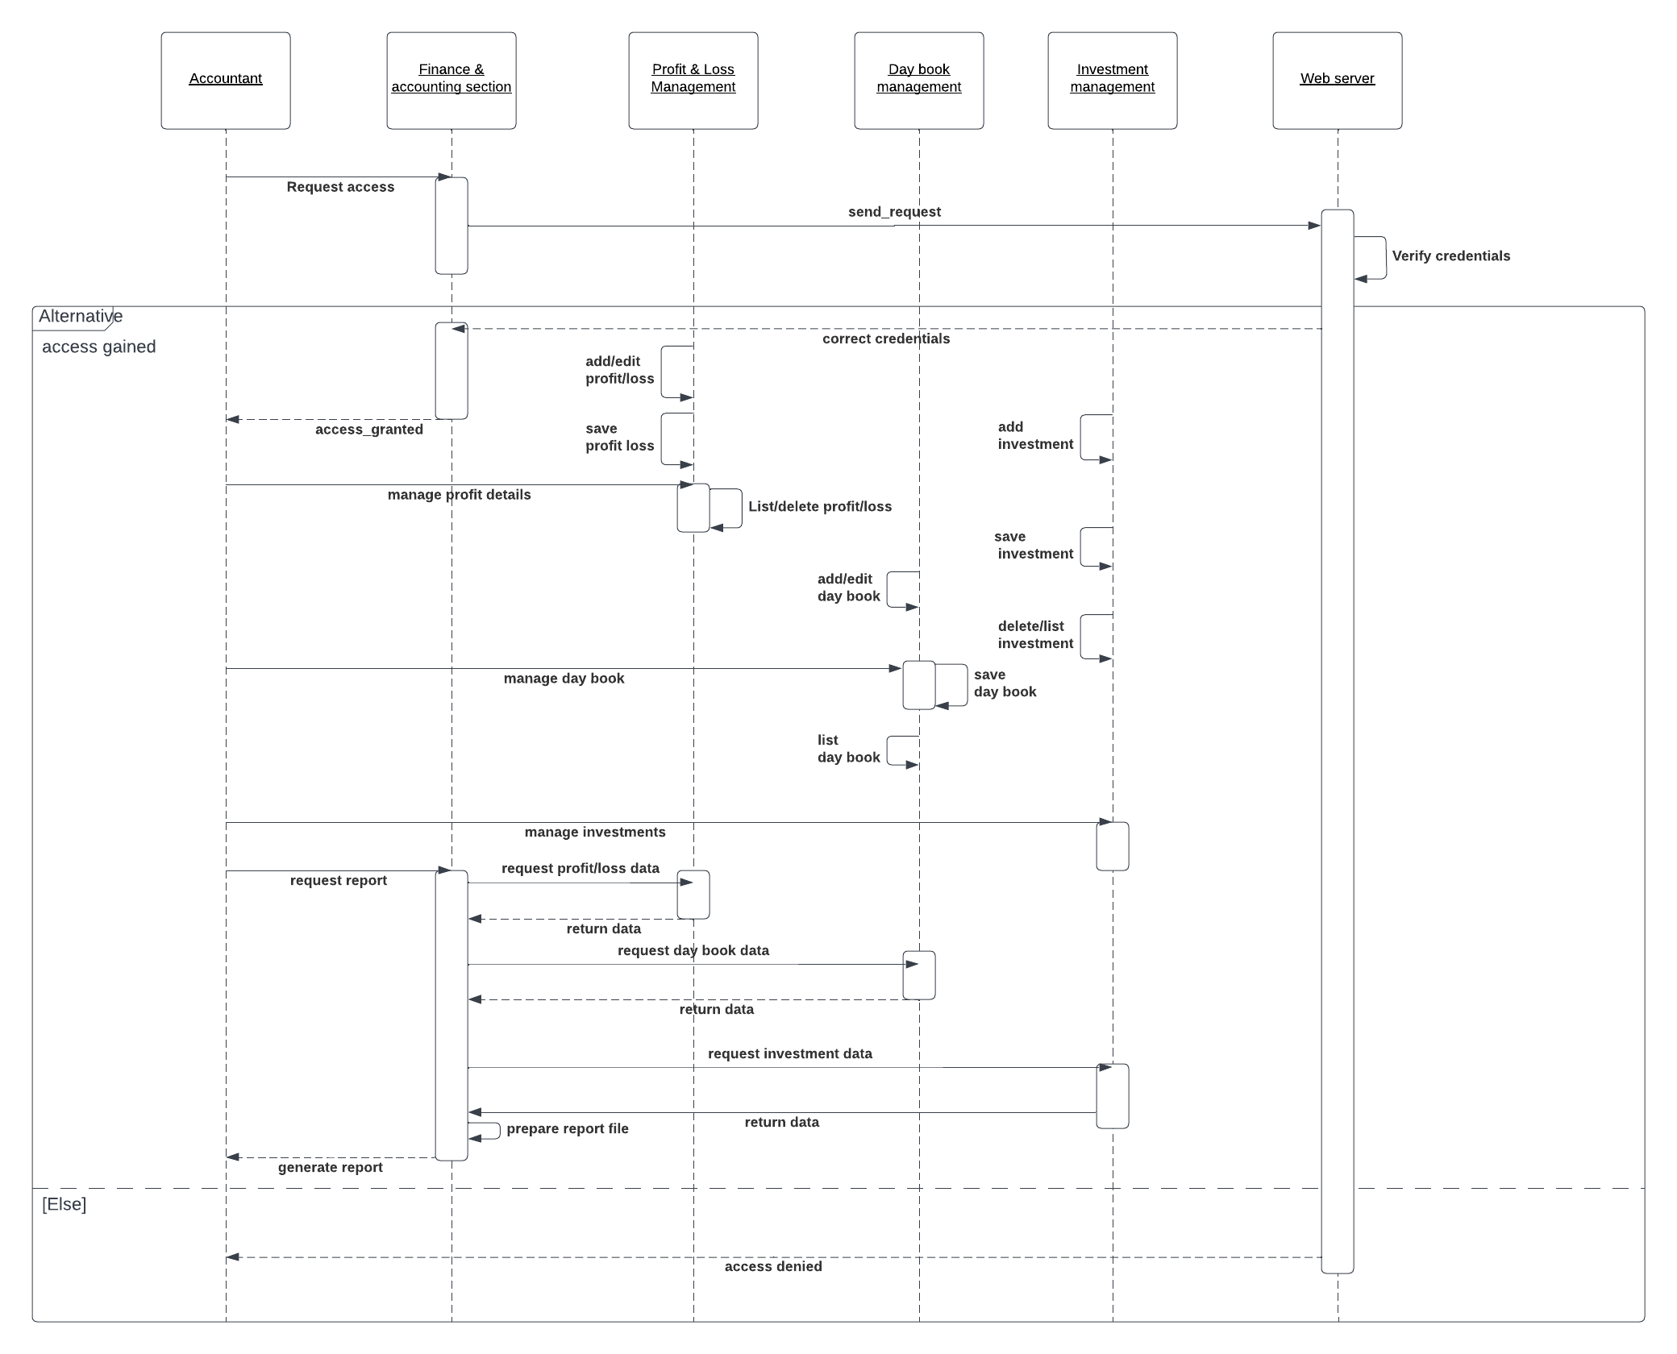Sequence diagram finance section

Sequence diagram human resource management

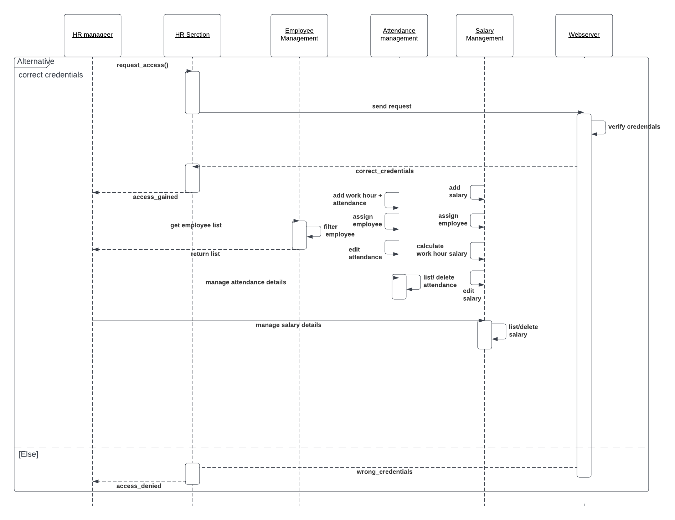

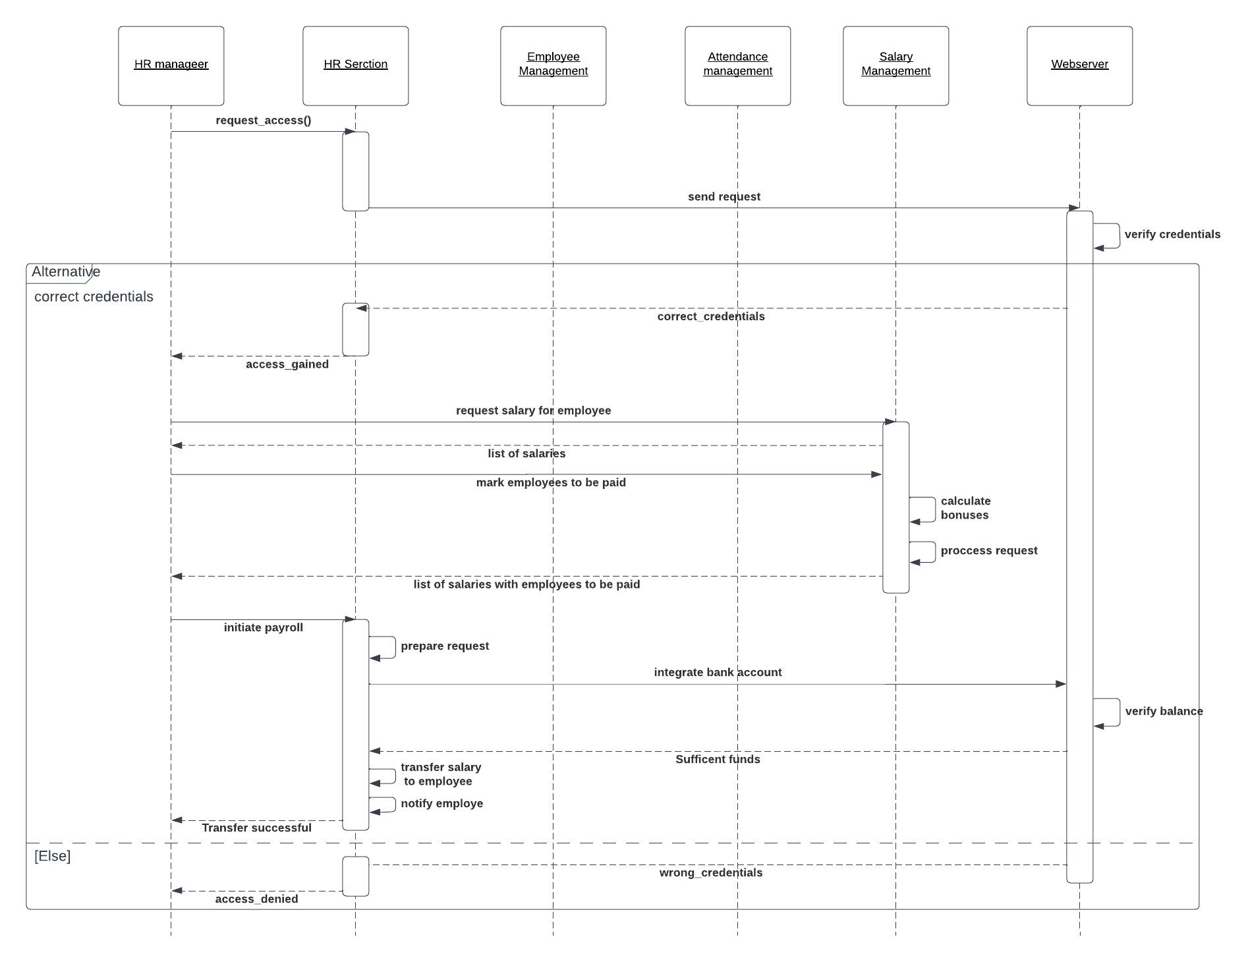Sequence diagram payroll management

Sequence diagram human resource report generation

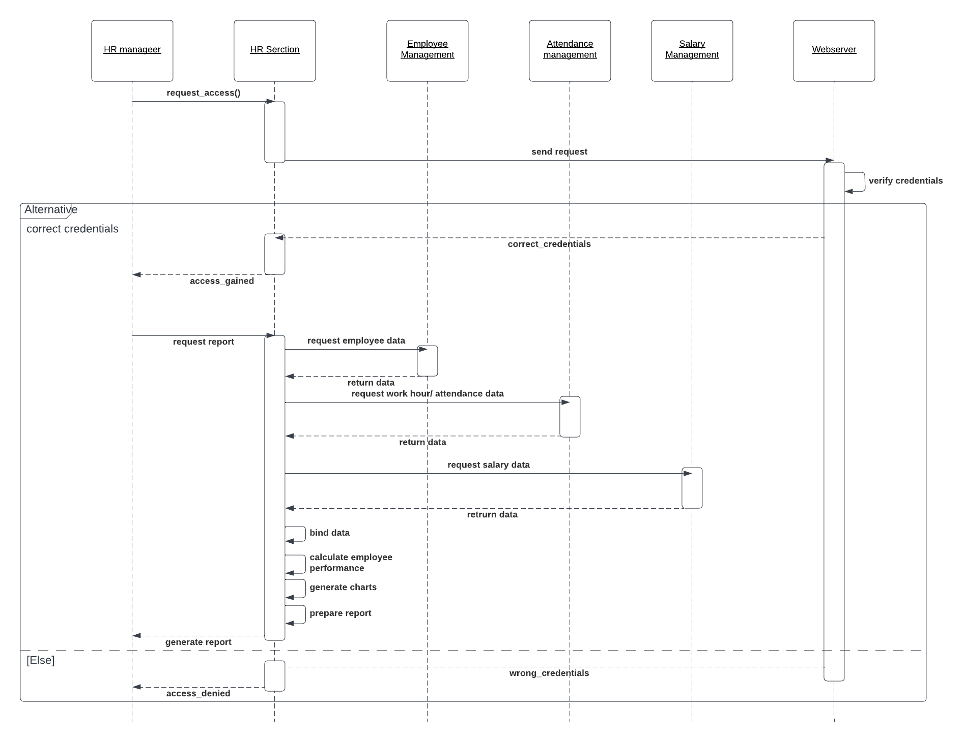

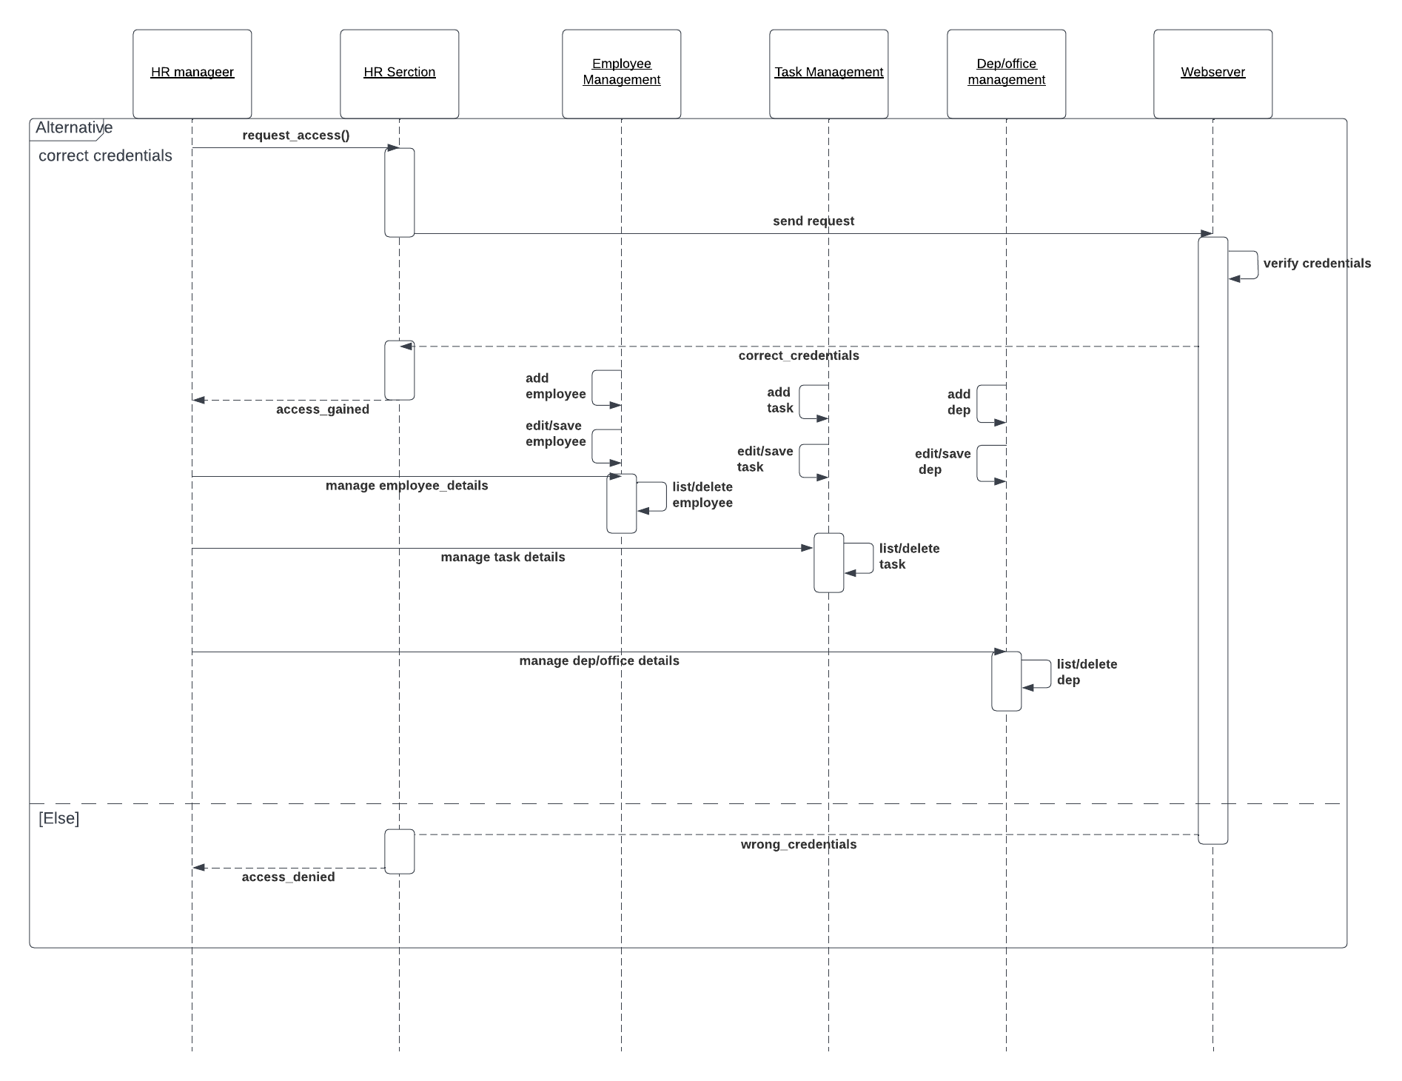Sequence diagram office management

Sequence diagram marketing automation

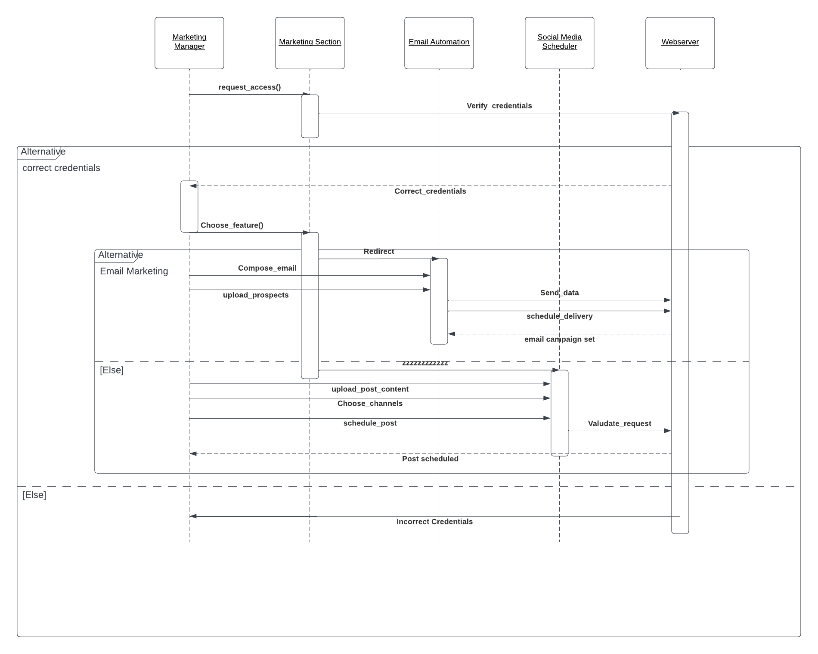

Sequence diagram office work report

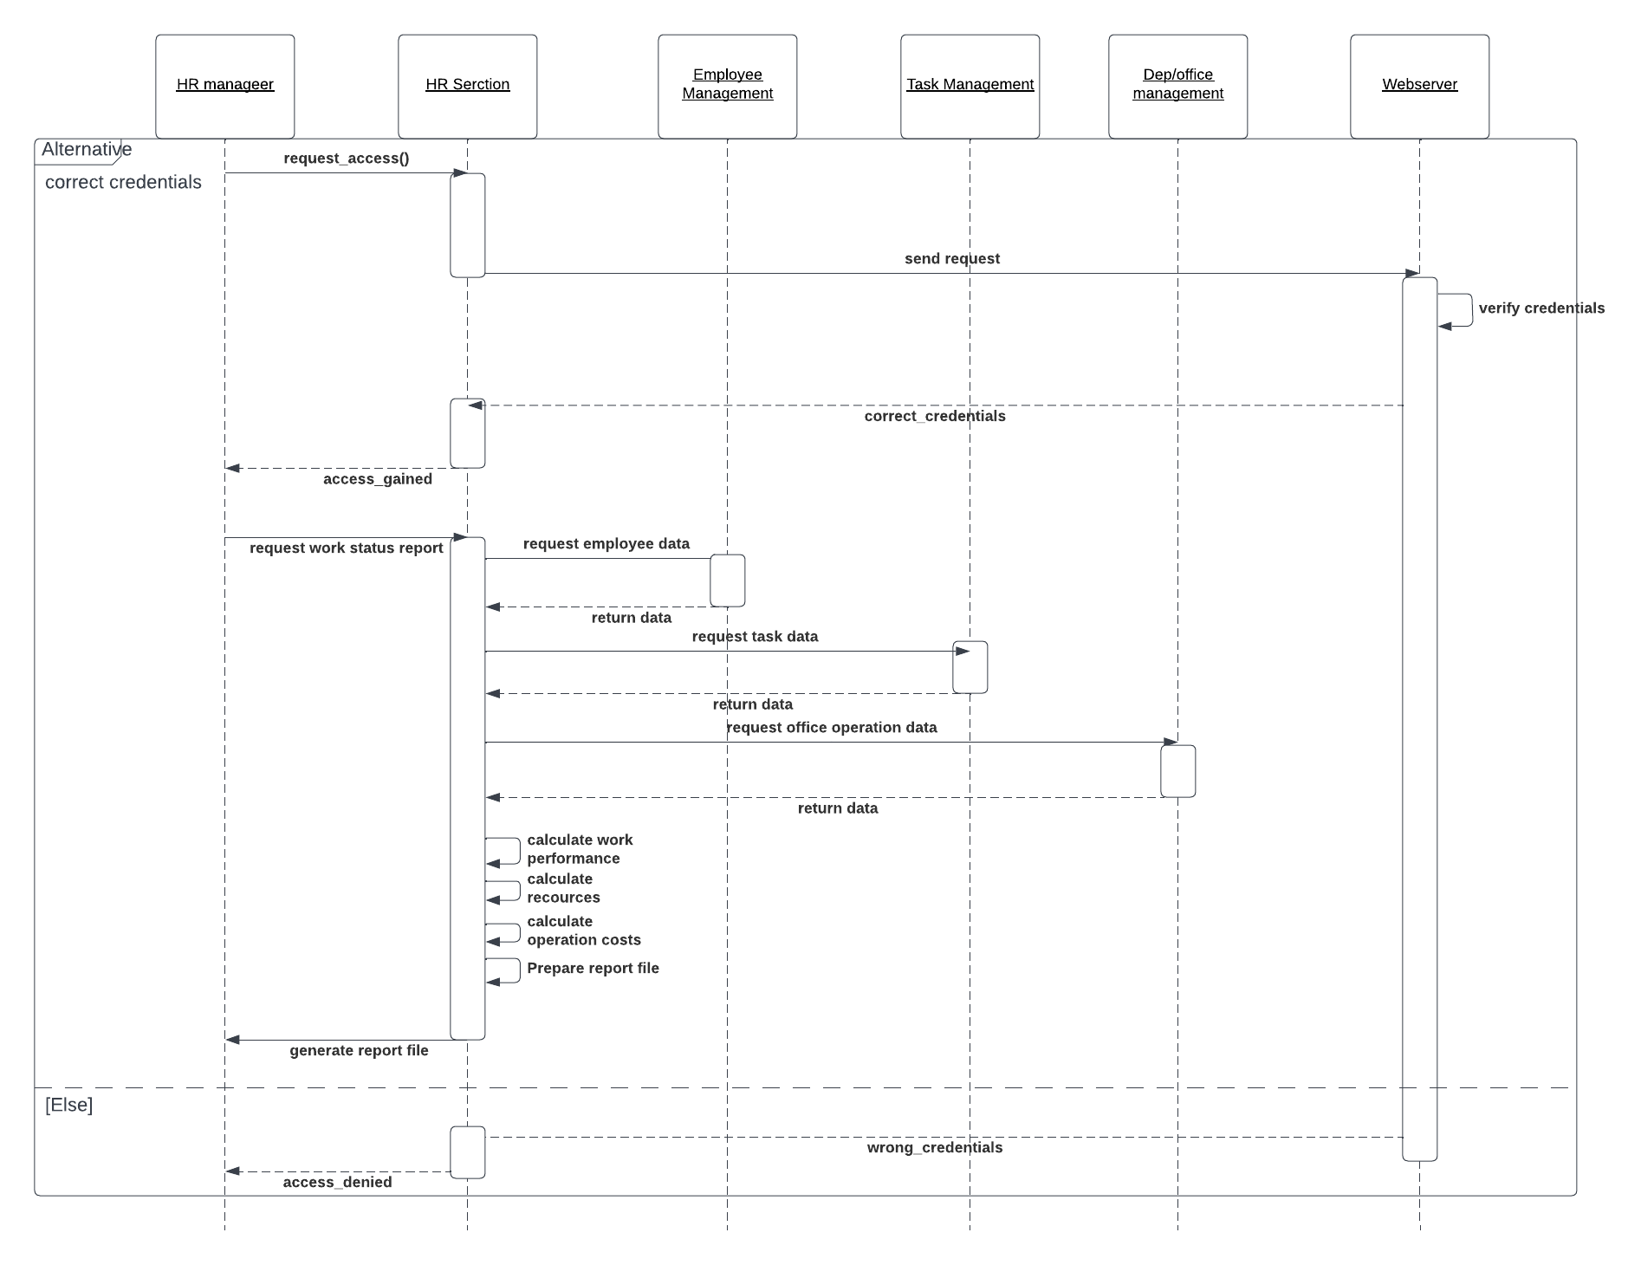

Sequence diagram store client

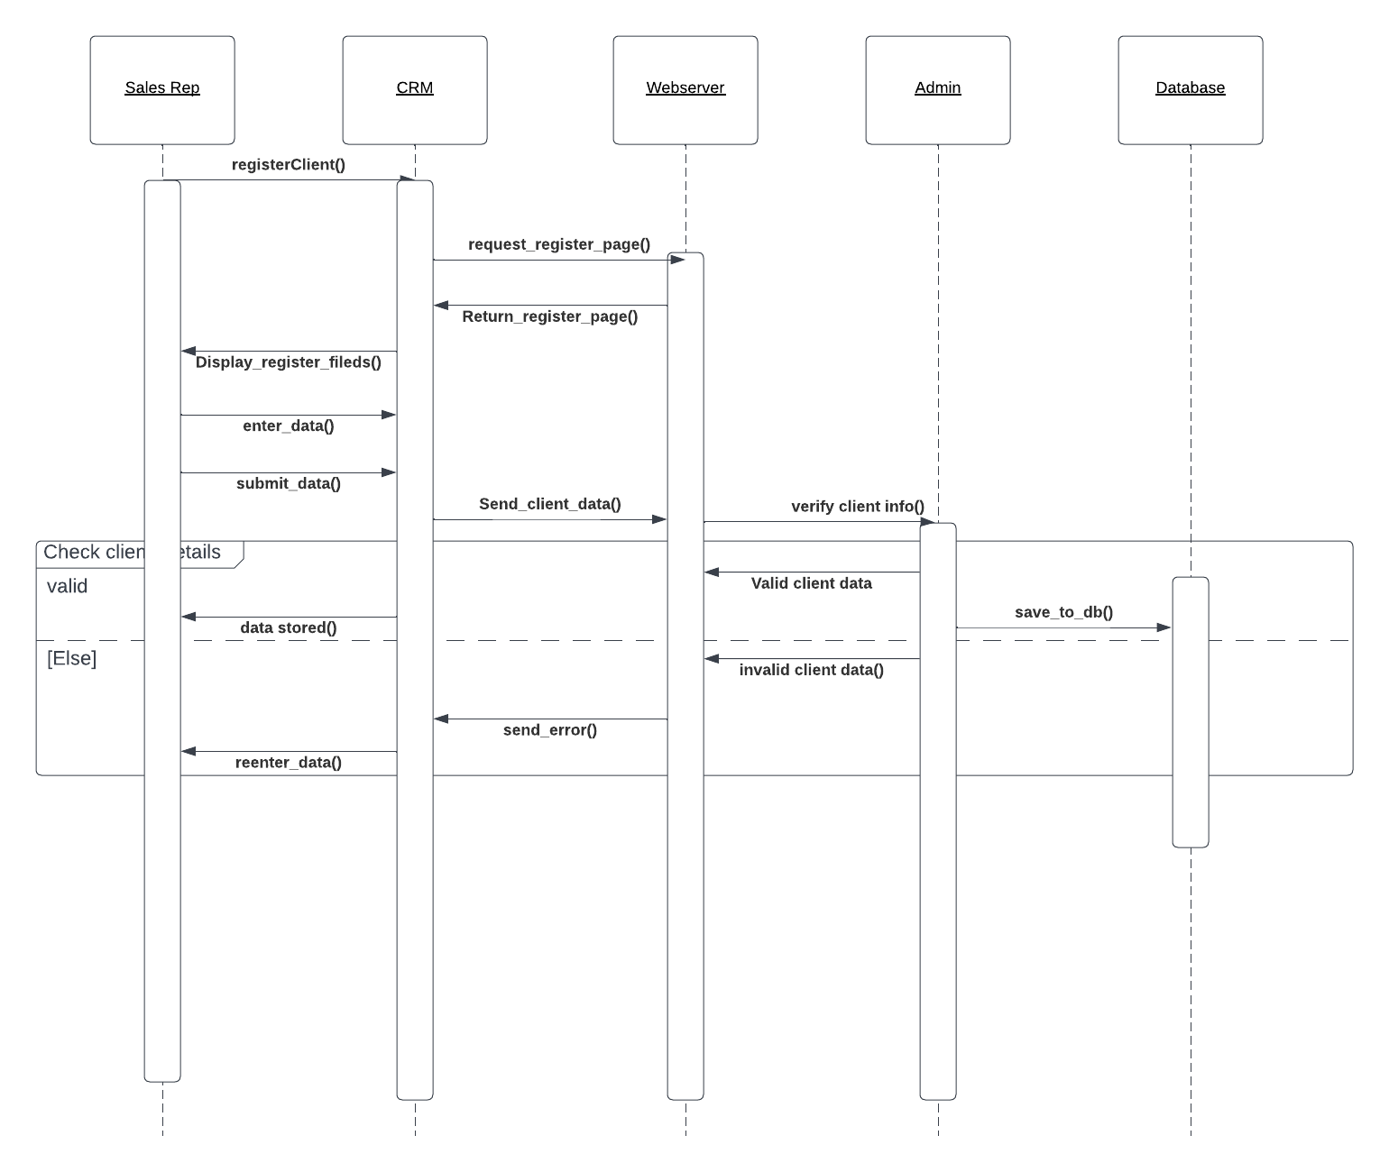

**4.6 Collaboration diagrams**

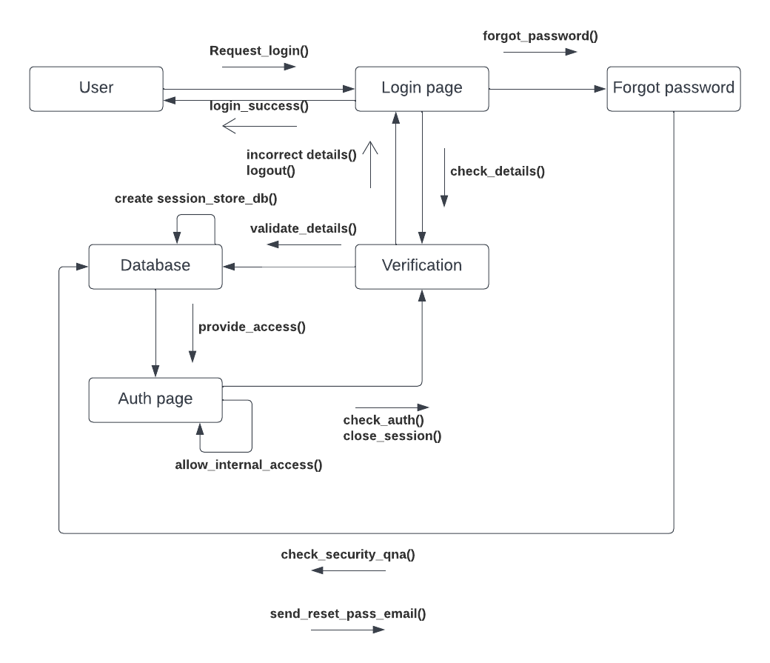Login to system collaboration diagram

Finance section collaboration diagram

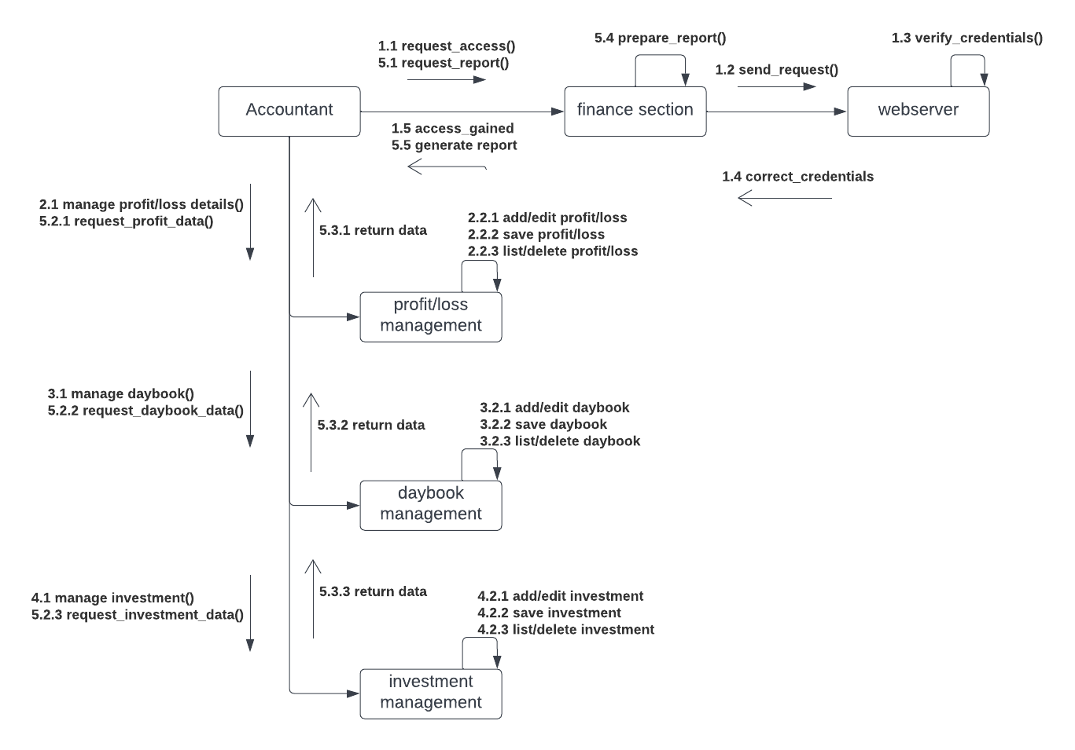

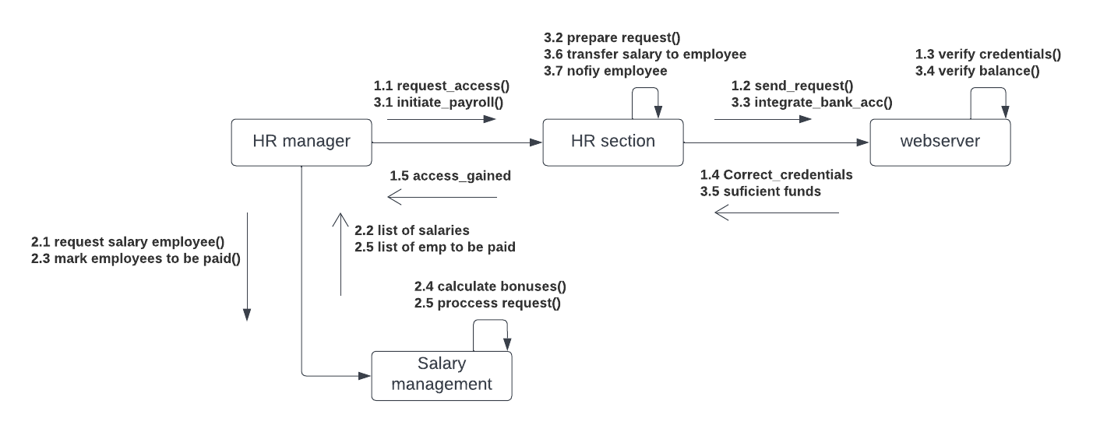Payroll collaboration diagram

Human resource management collaboration diagram

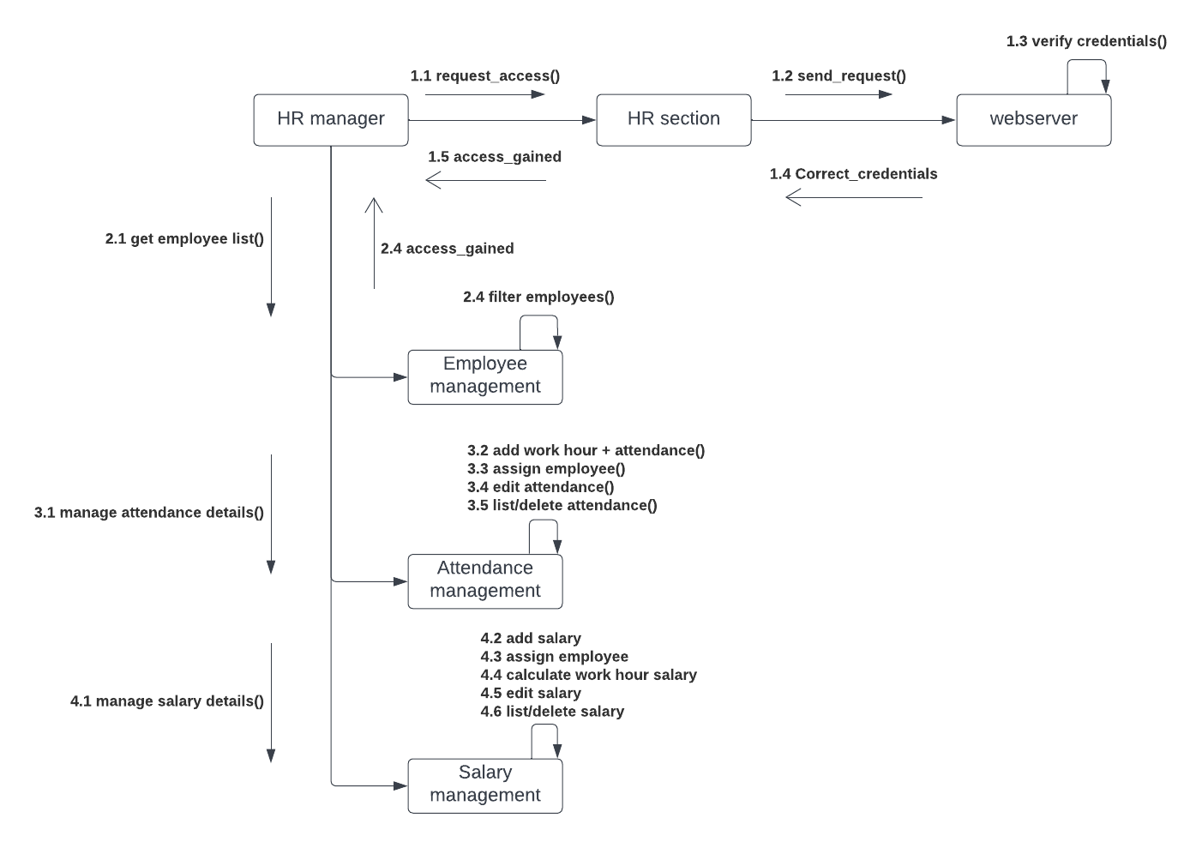

Human resource report collaboration diagram

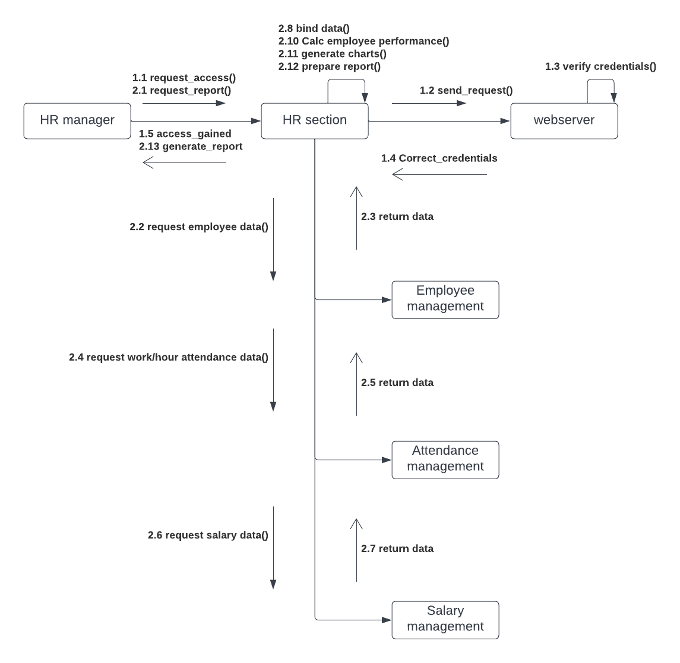

Sales section collaboration diagram

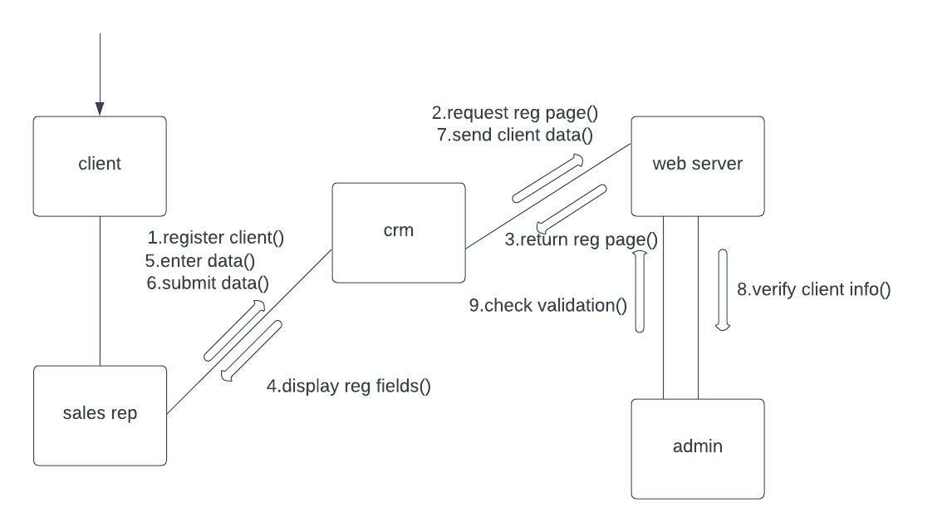

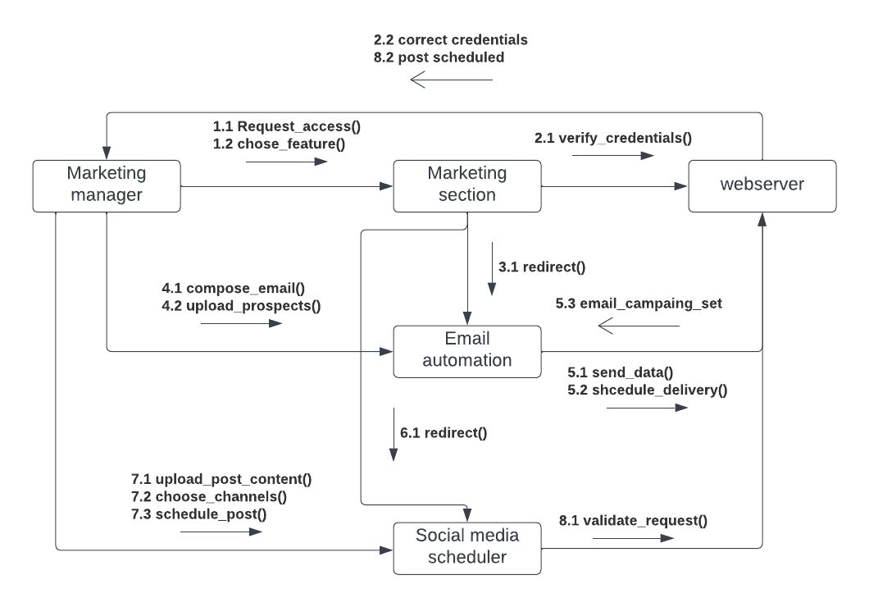Marketing automation collaboration diagram

**4.7 BPMN diagrams**

Quote request BPMN diagram

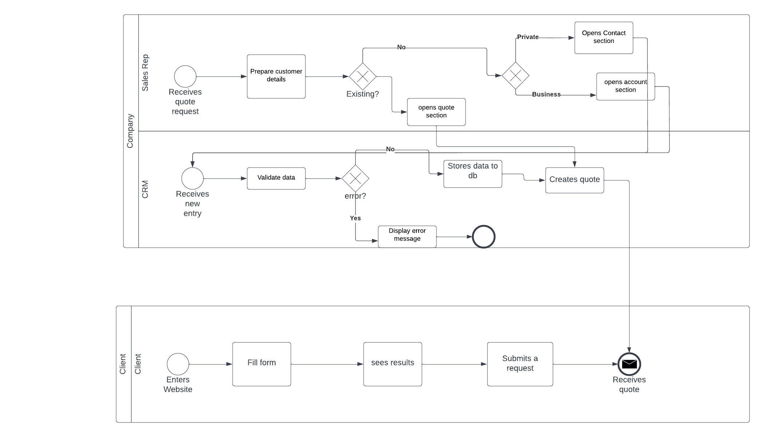

Employee leave request BPMN diagram

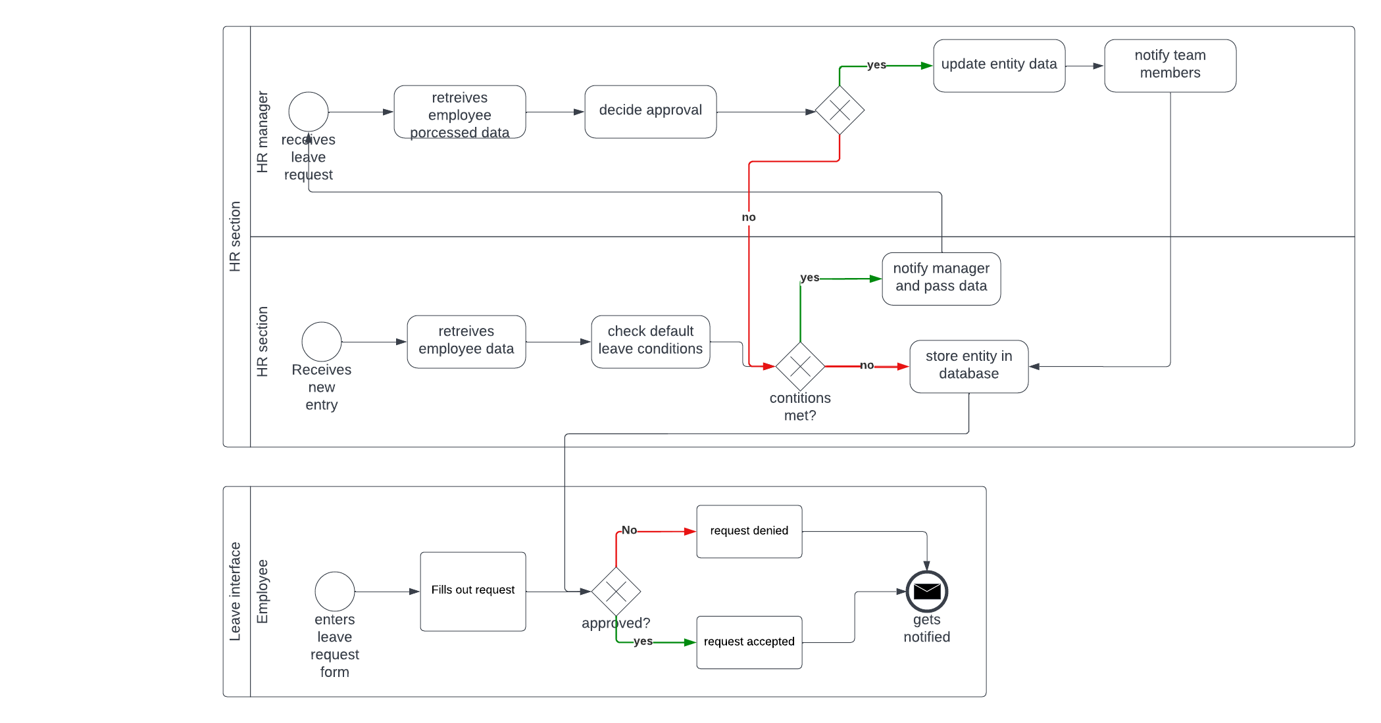

Social media post approval BPMN diagram

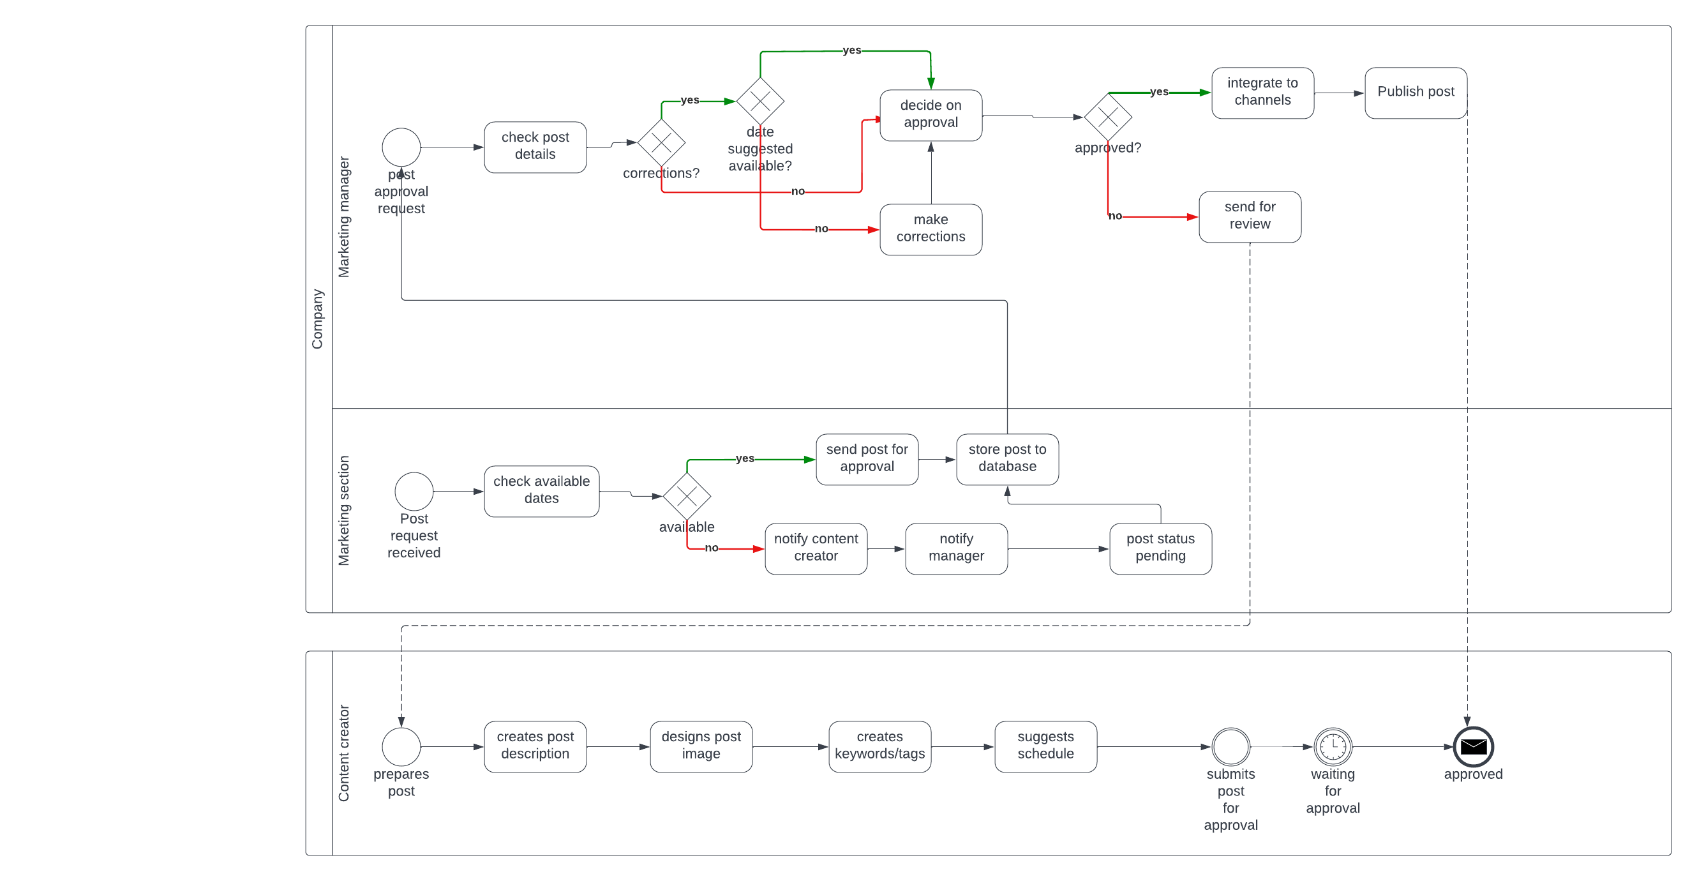

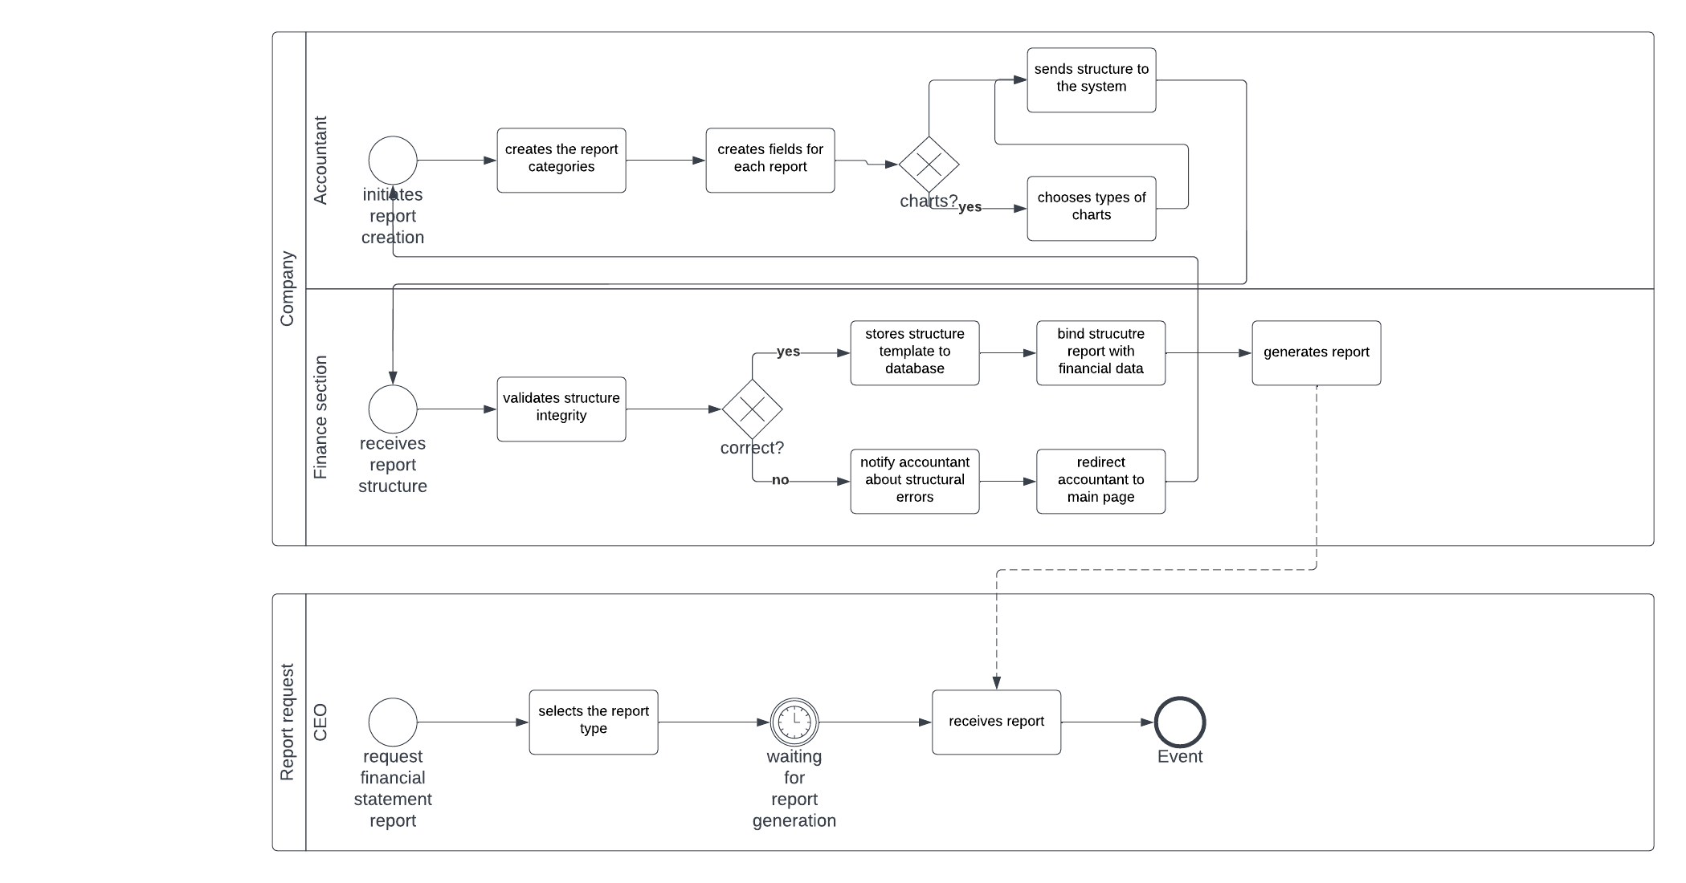Financial report request BPMN diagram

**4.8 Class diagrams**

Sales section class diagram

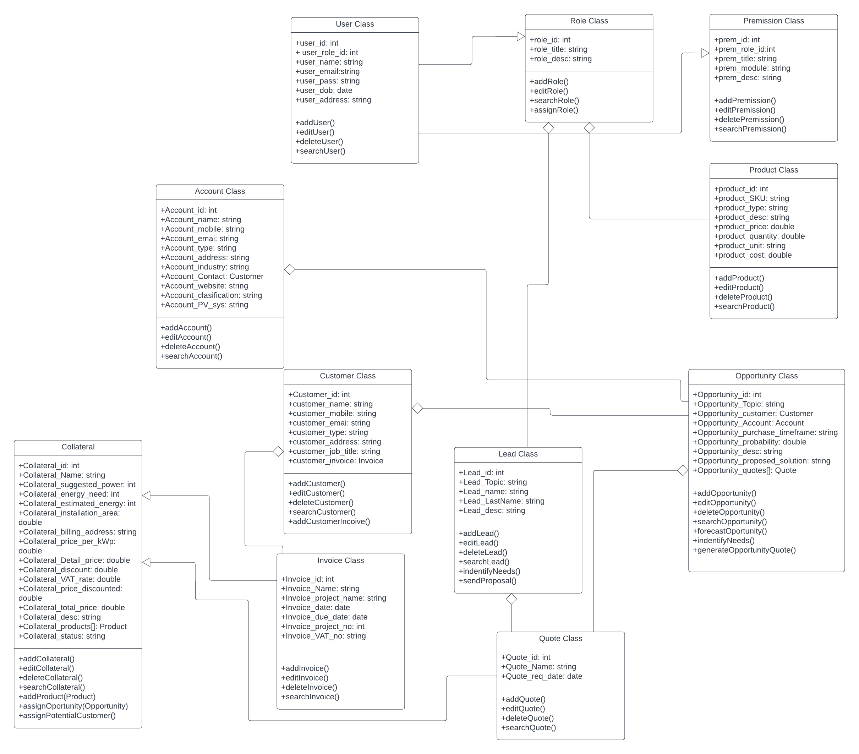

Marketing section class diagram

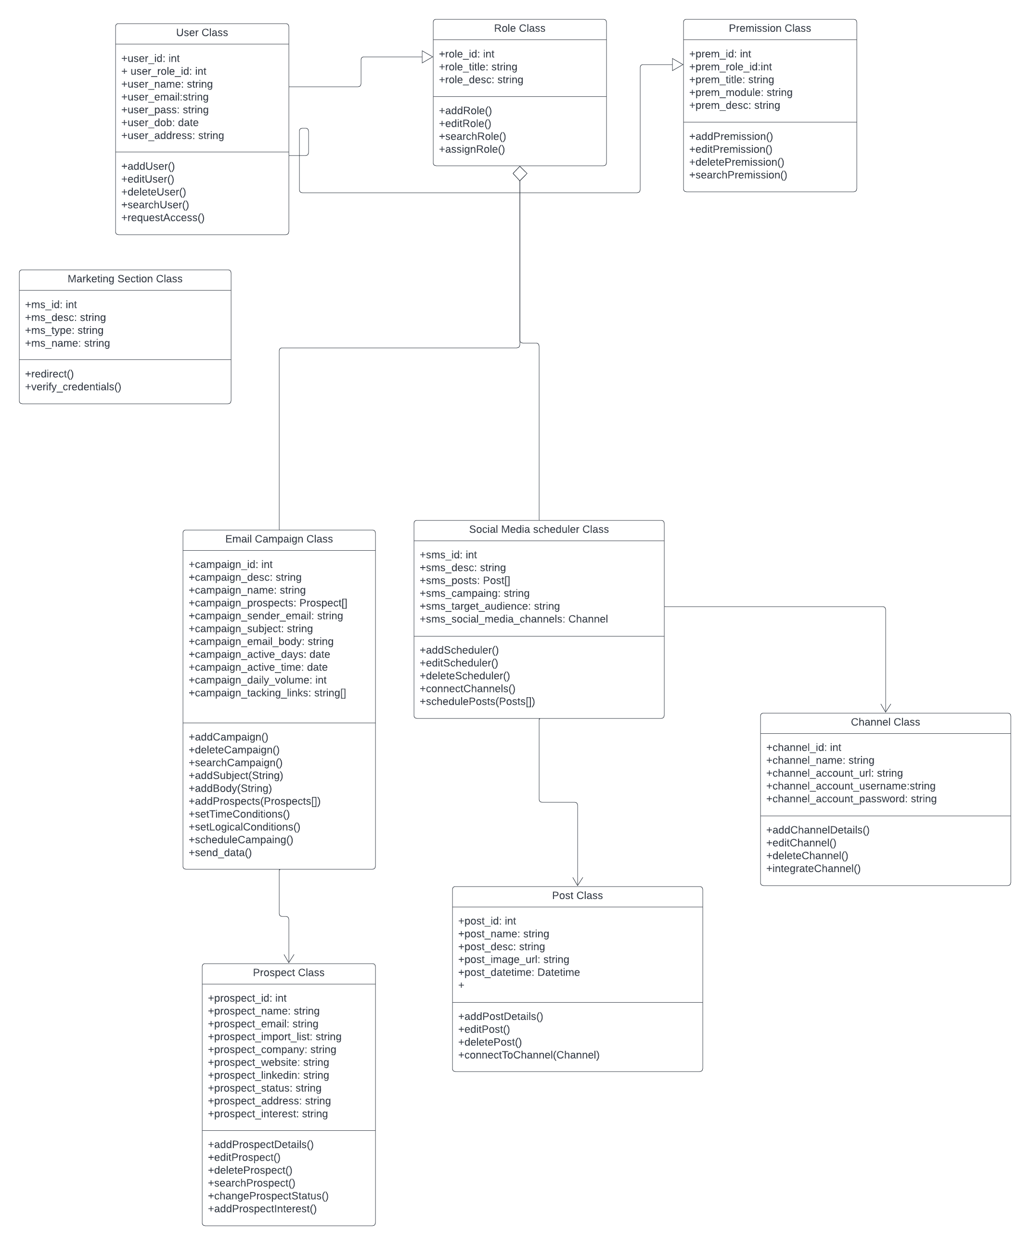

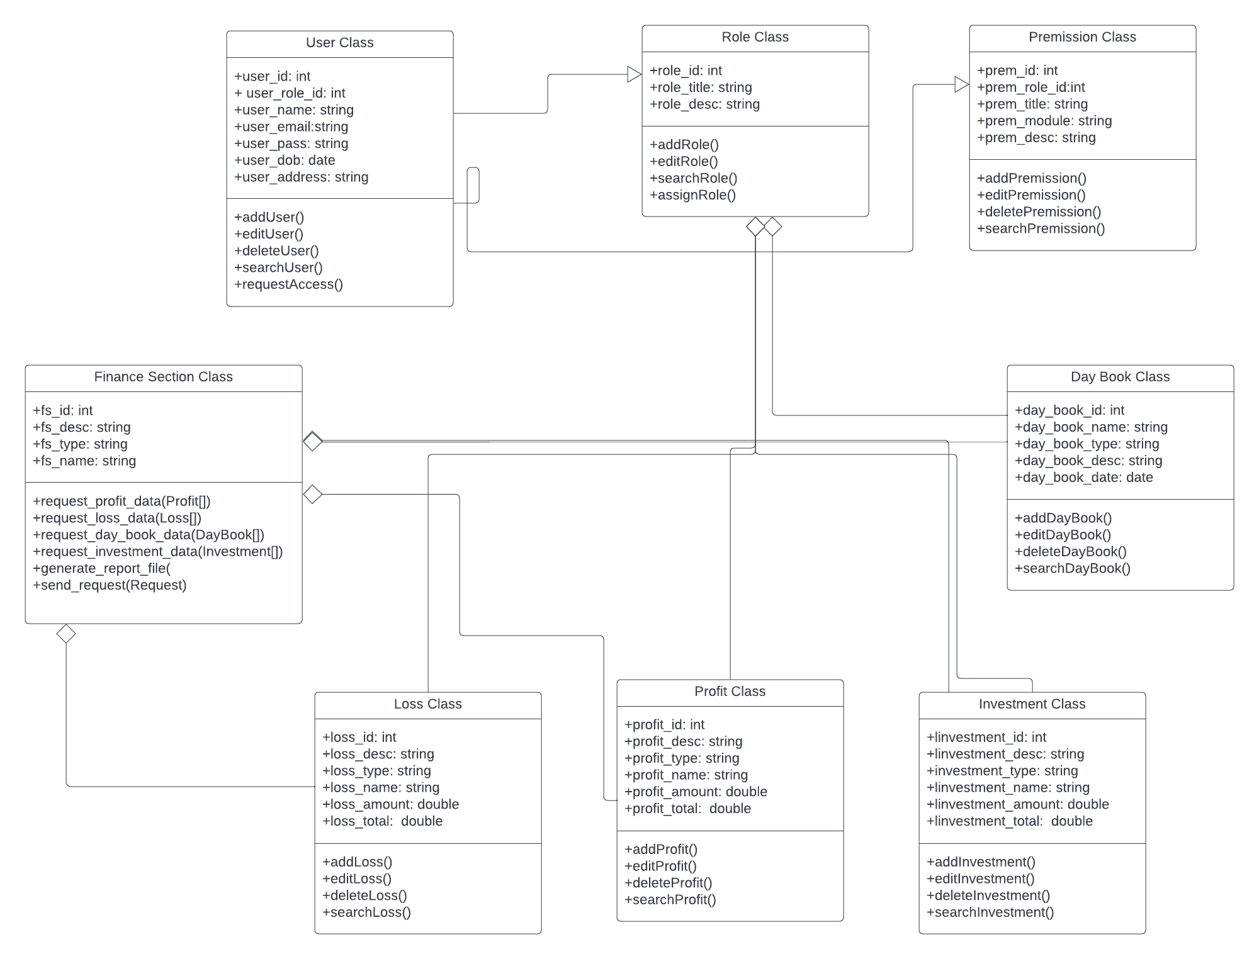Finance section class diagram

Human resource section class diagram

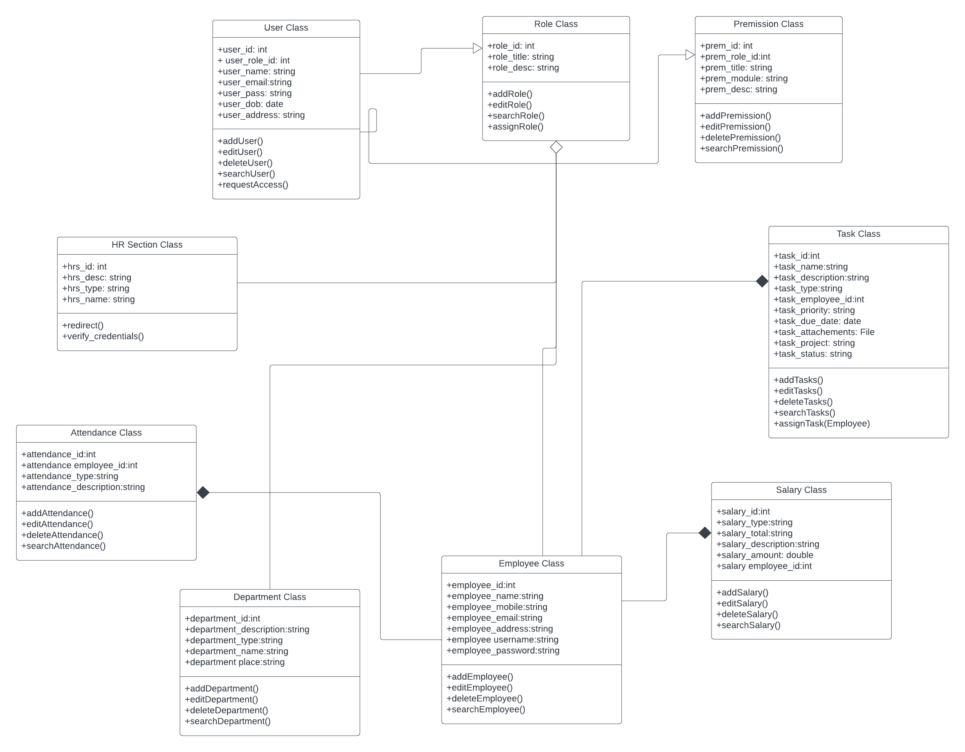

**4.9 Entity Relation Diagrams**

Sales section ERD

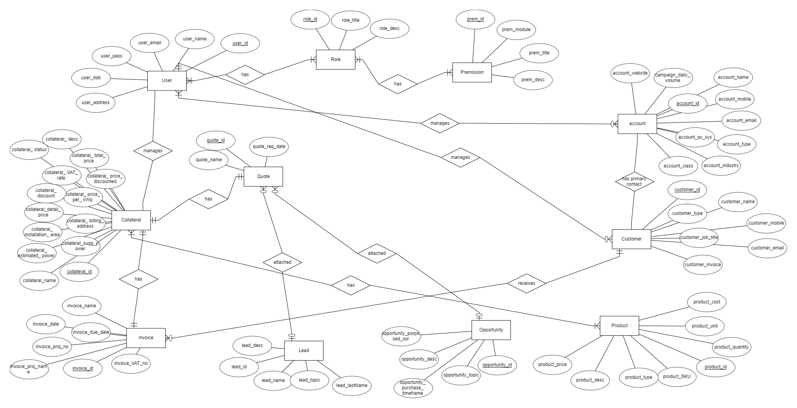

Marketing section ERD

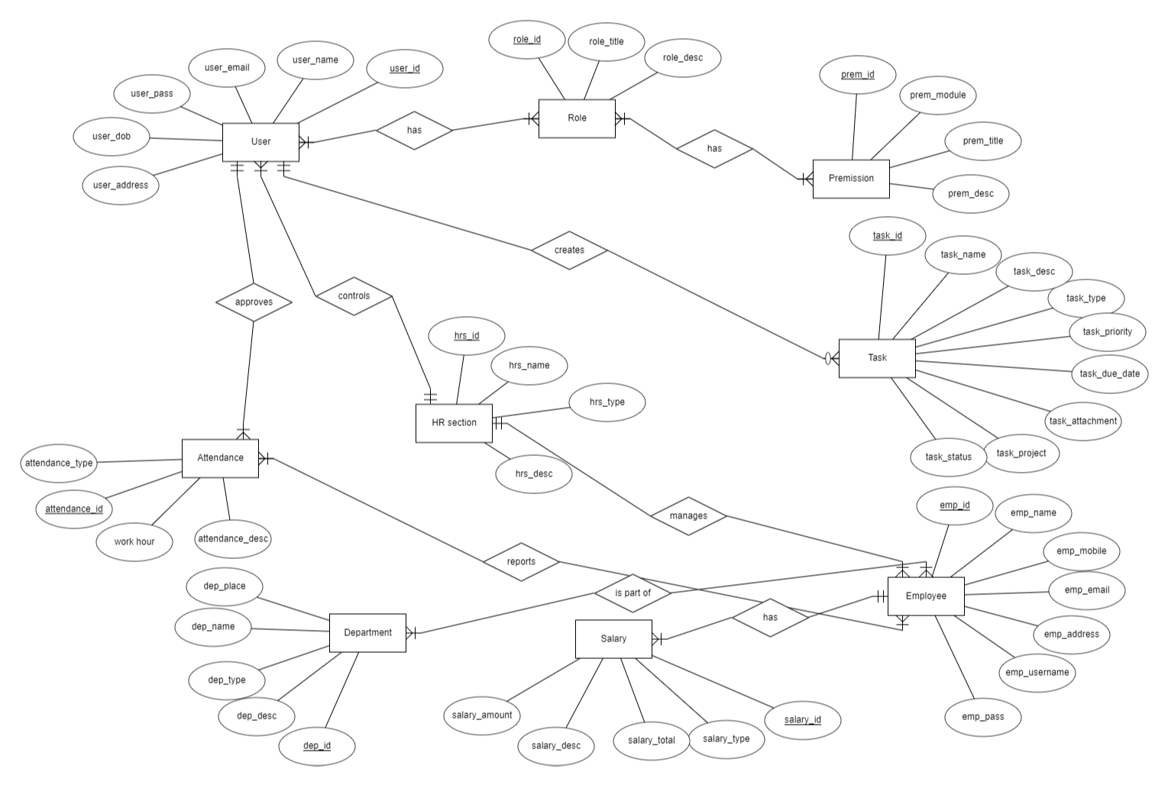

Finance section ERD

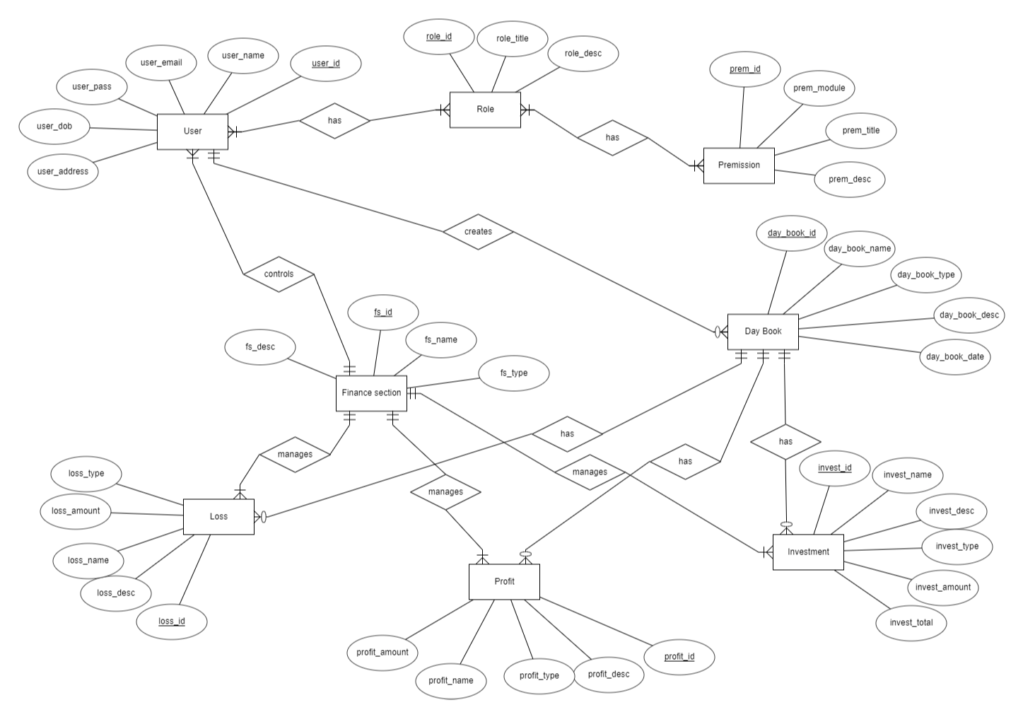

Human resource ERD

**4.10 Object Diagrams**

Sales section object diagram

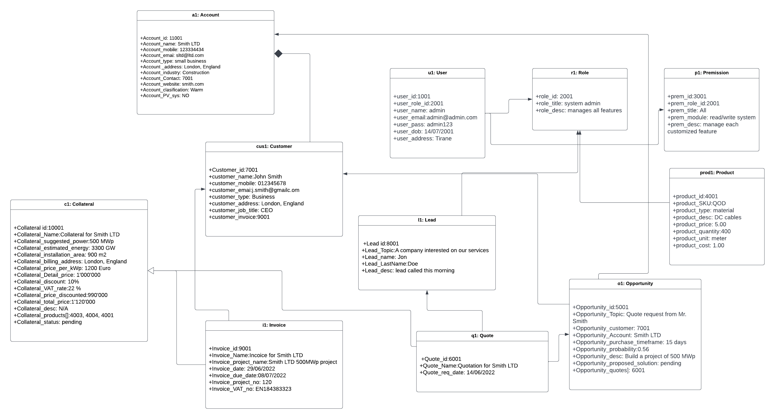

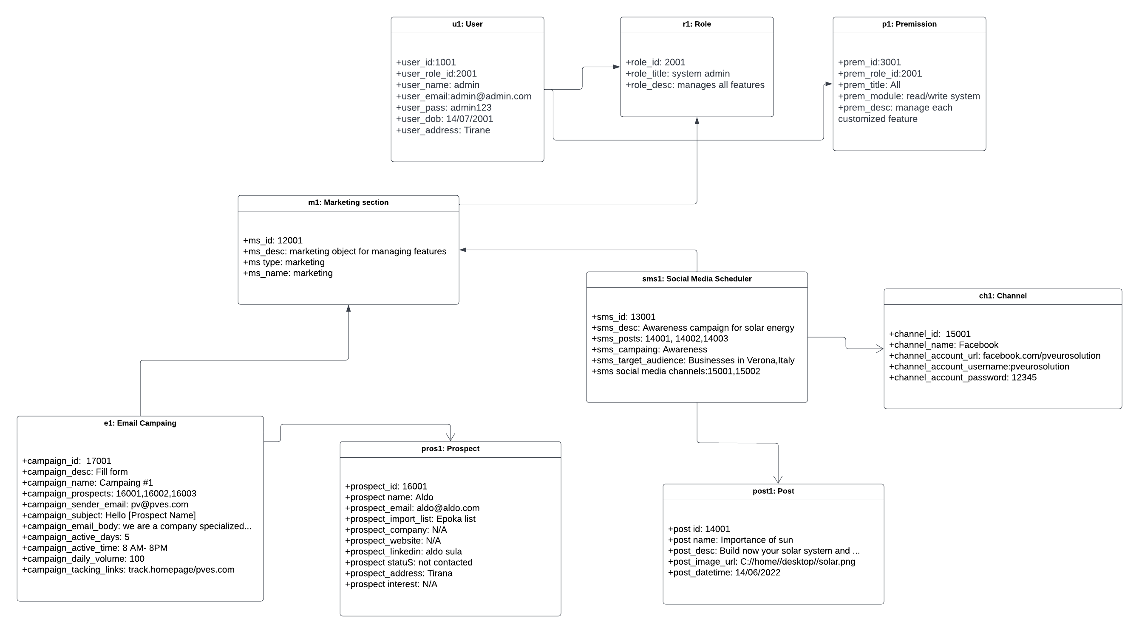Marketing section object diagram

Finance section object diagram

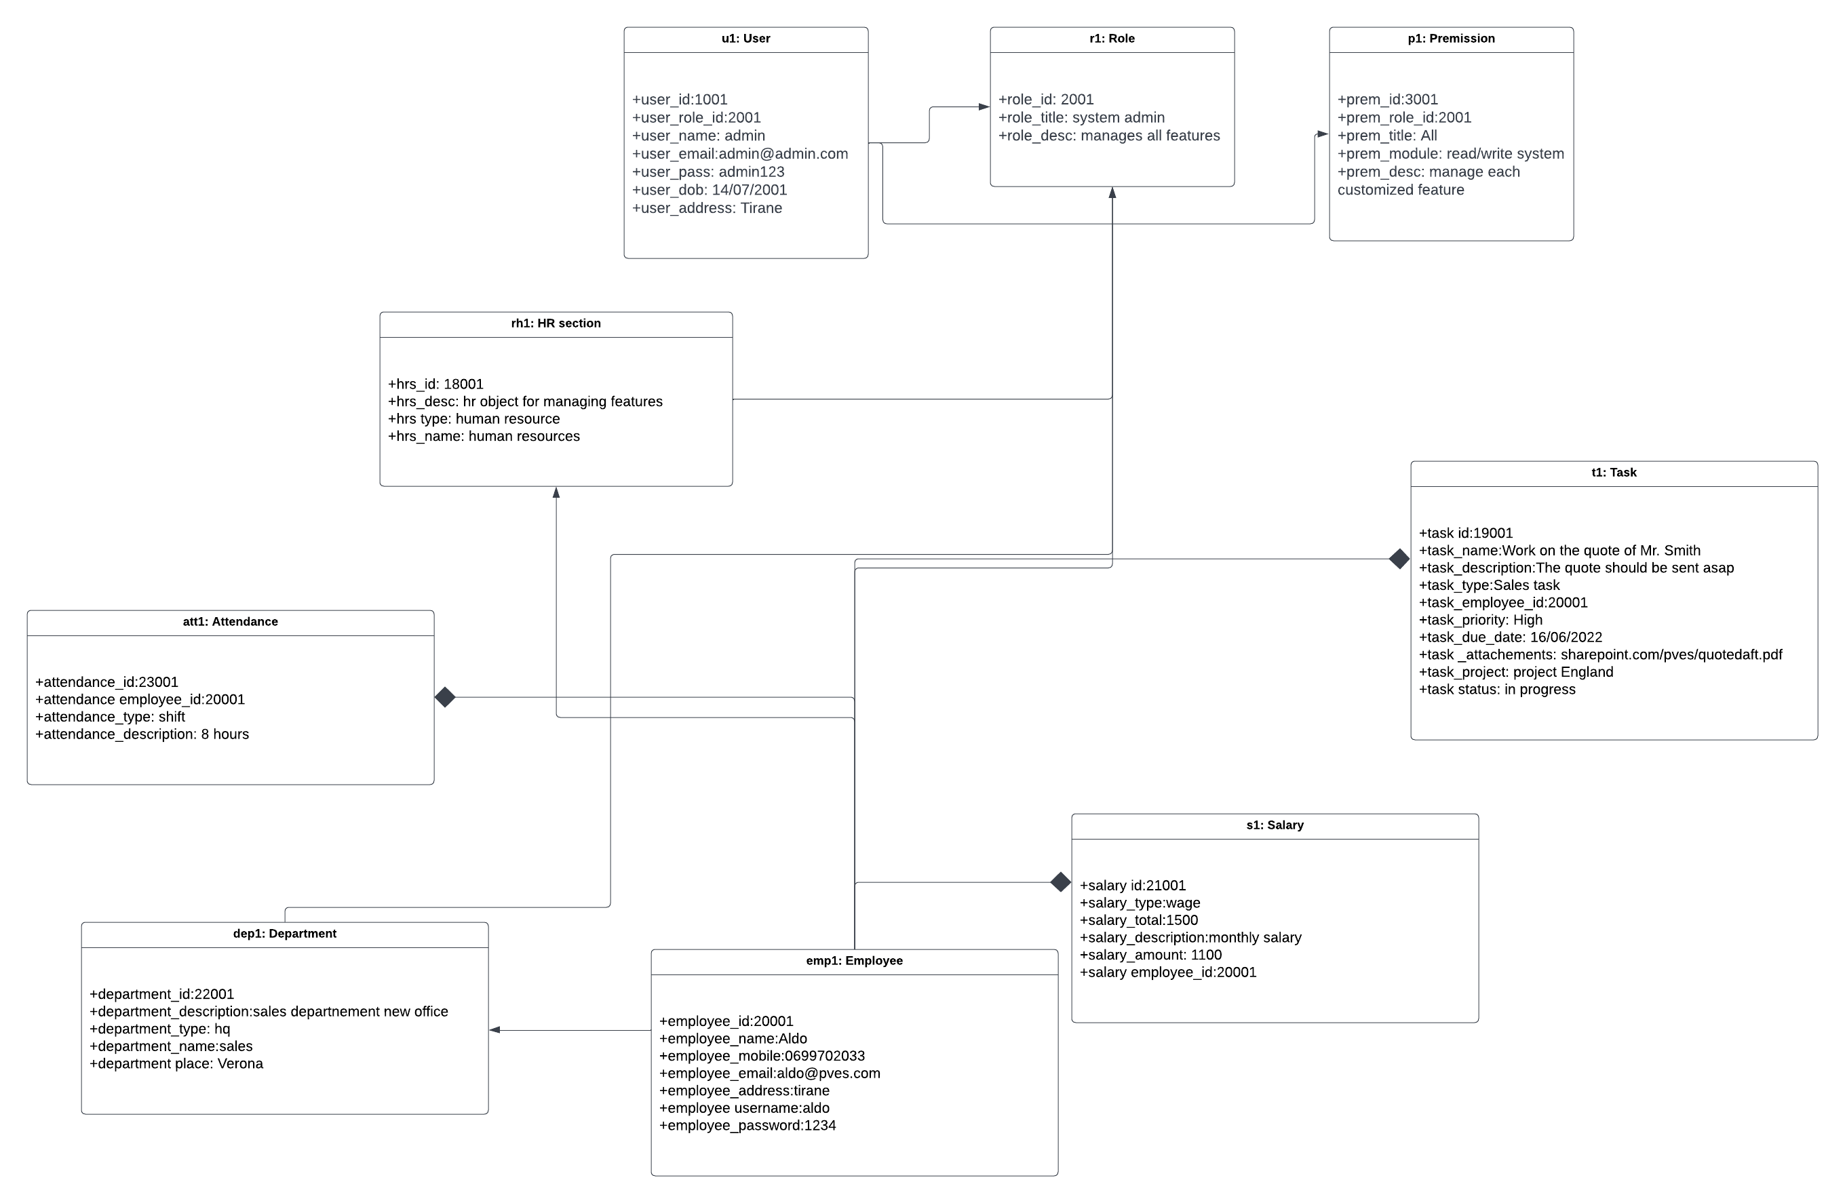

Human resources object diagram

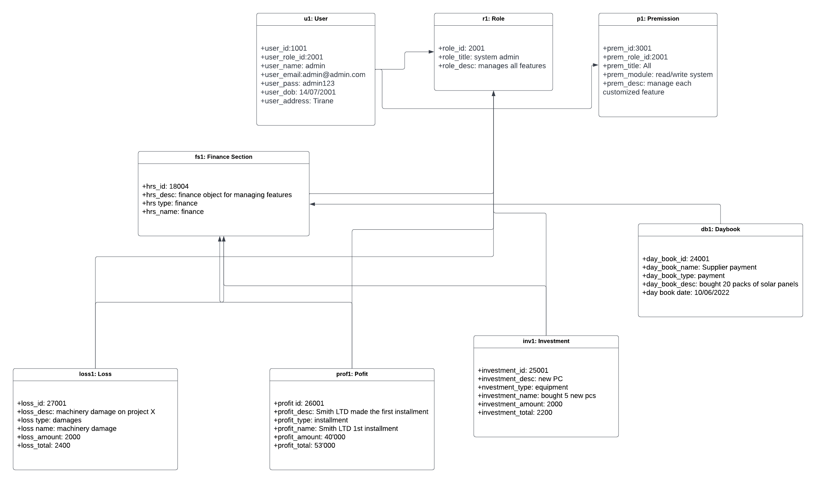

**4.11 State diagrams**

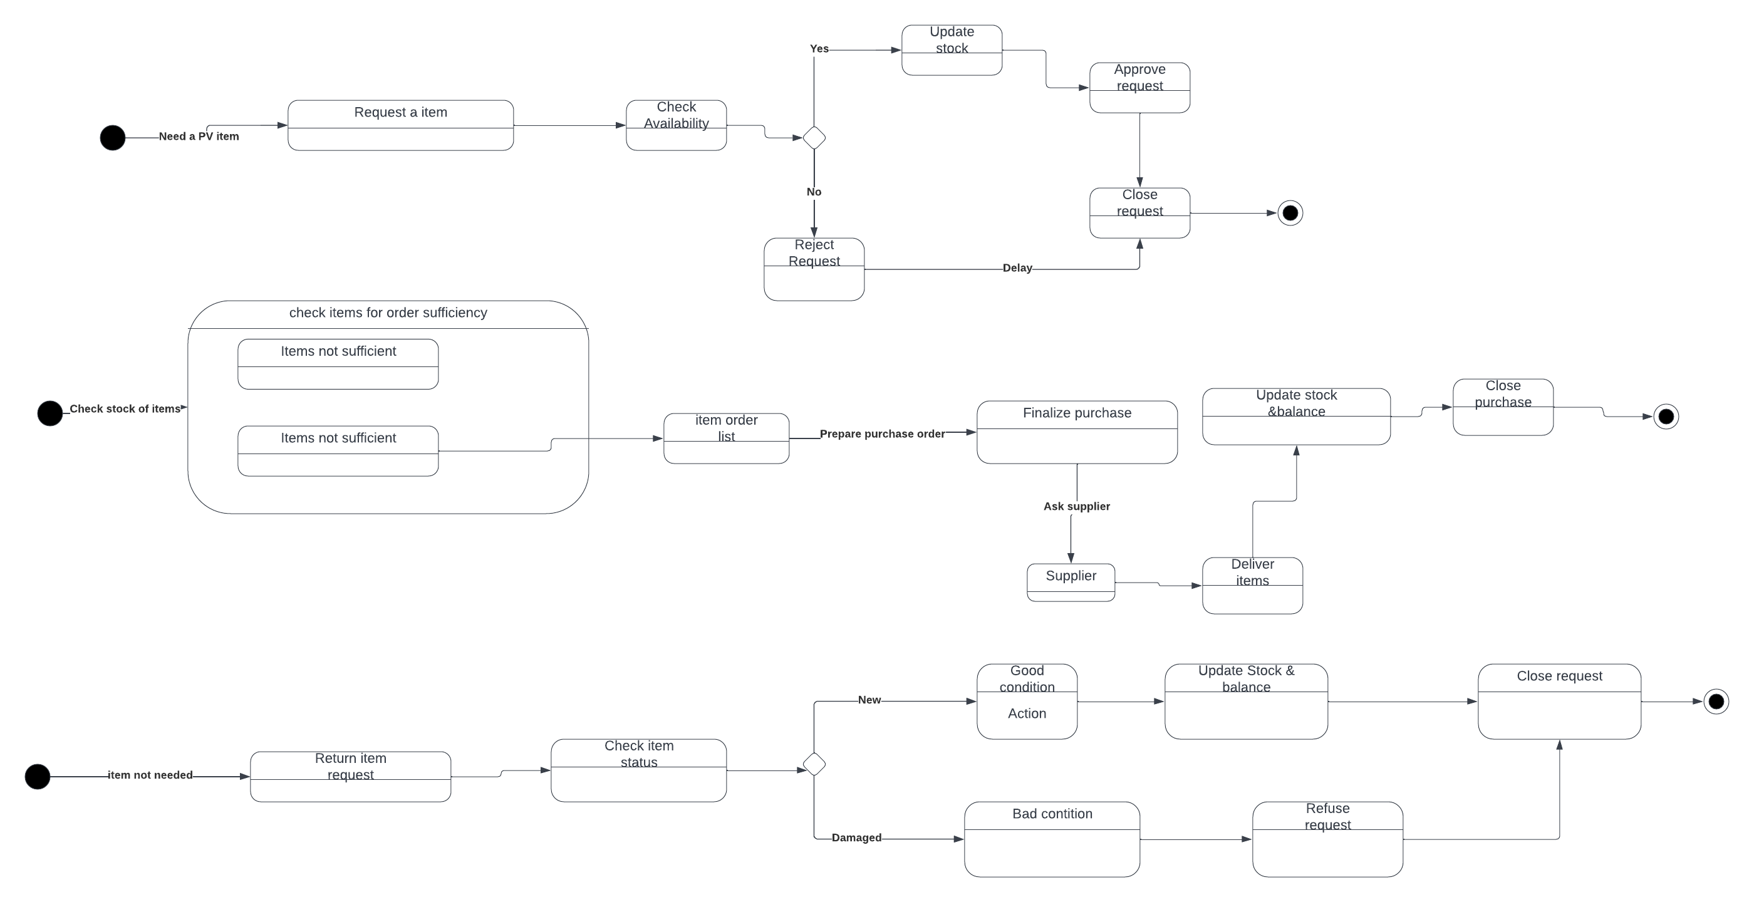Photovolatic system request state diagram

Product check state diagram



Product return state diagram



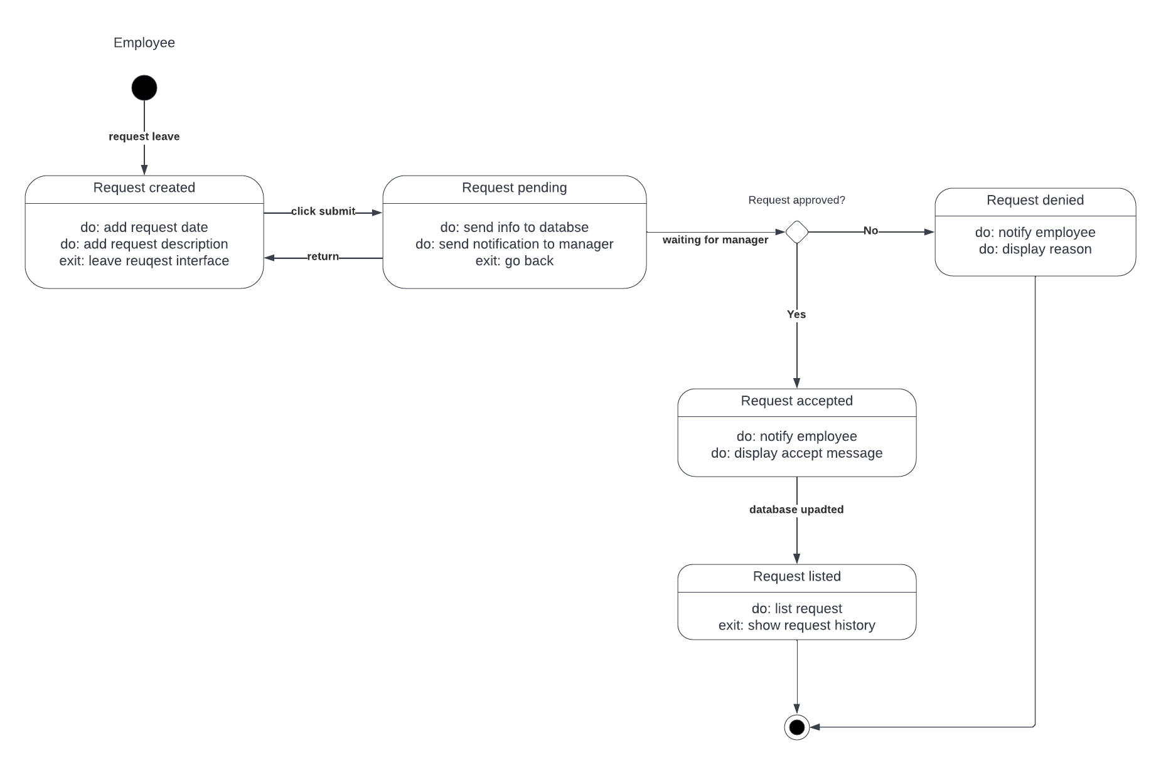Leave management state diagram

Opportunity state diagram

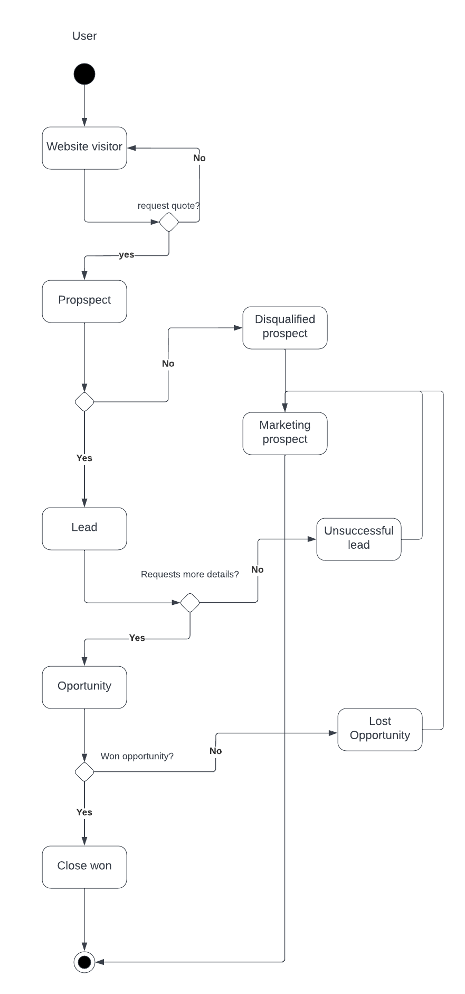

**4.12 Data flow diagrams**

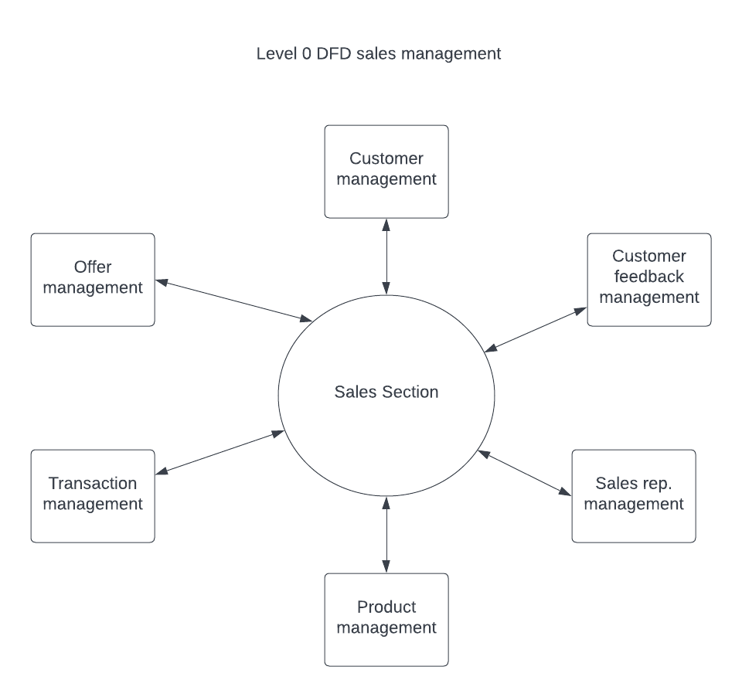Level 0 DFD sales management

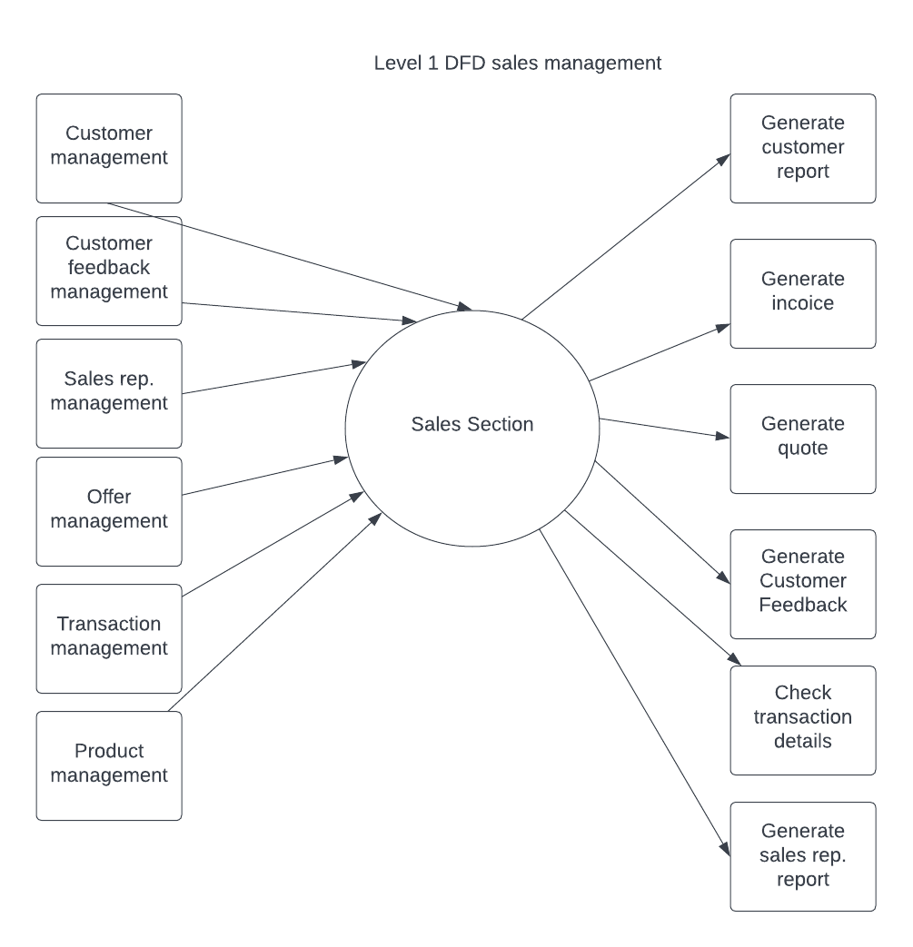Level 1 DFD sales management

Level 2 DFD sales management

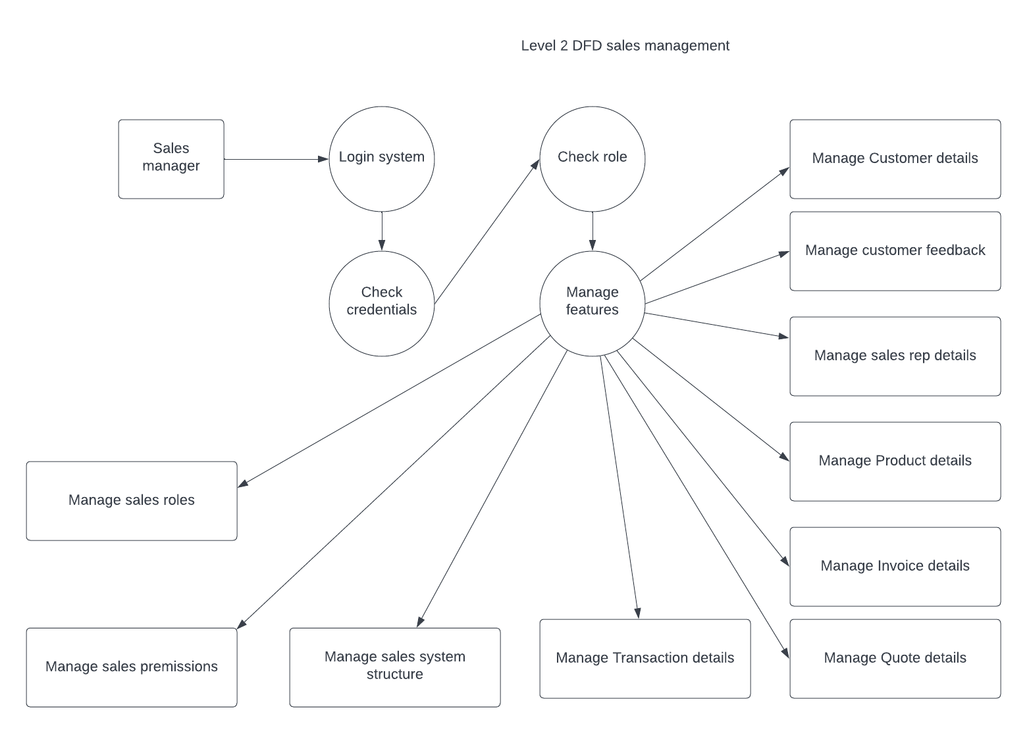

Level 0 DFD marketing management

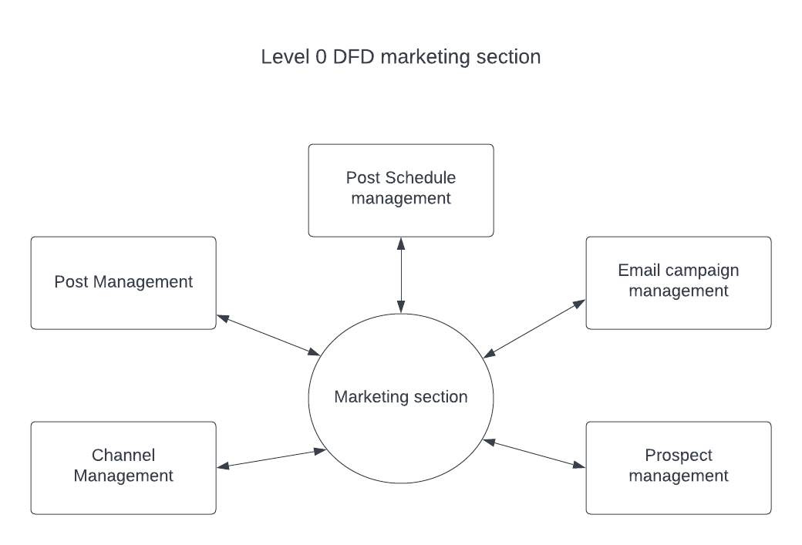

Level 1 DFD marketing management

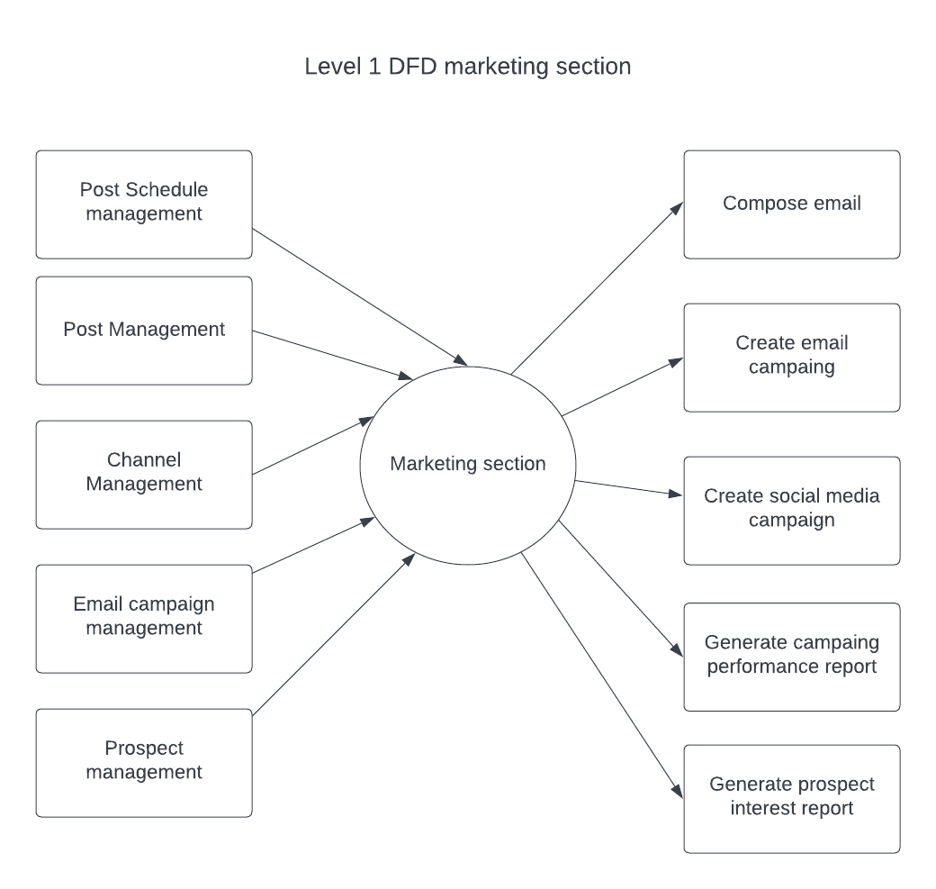

Level 2 DFD marketing management

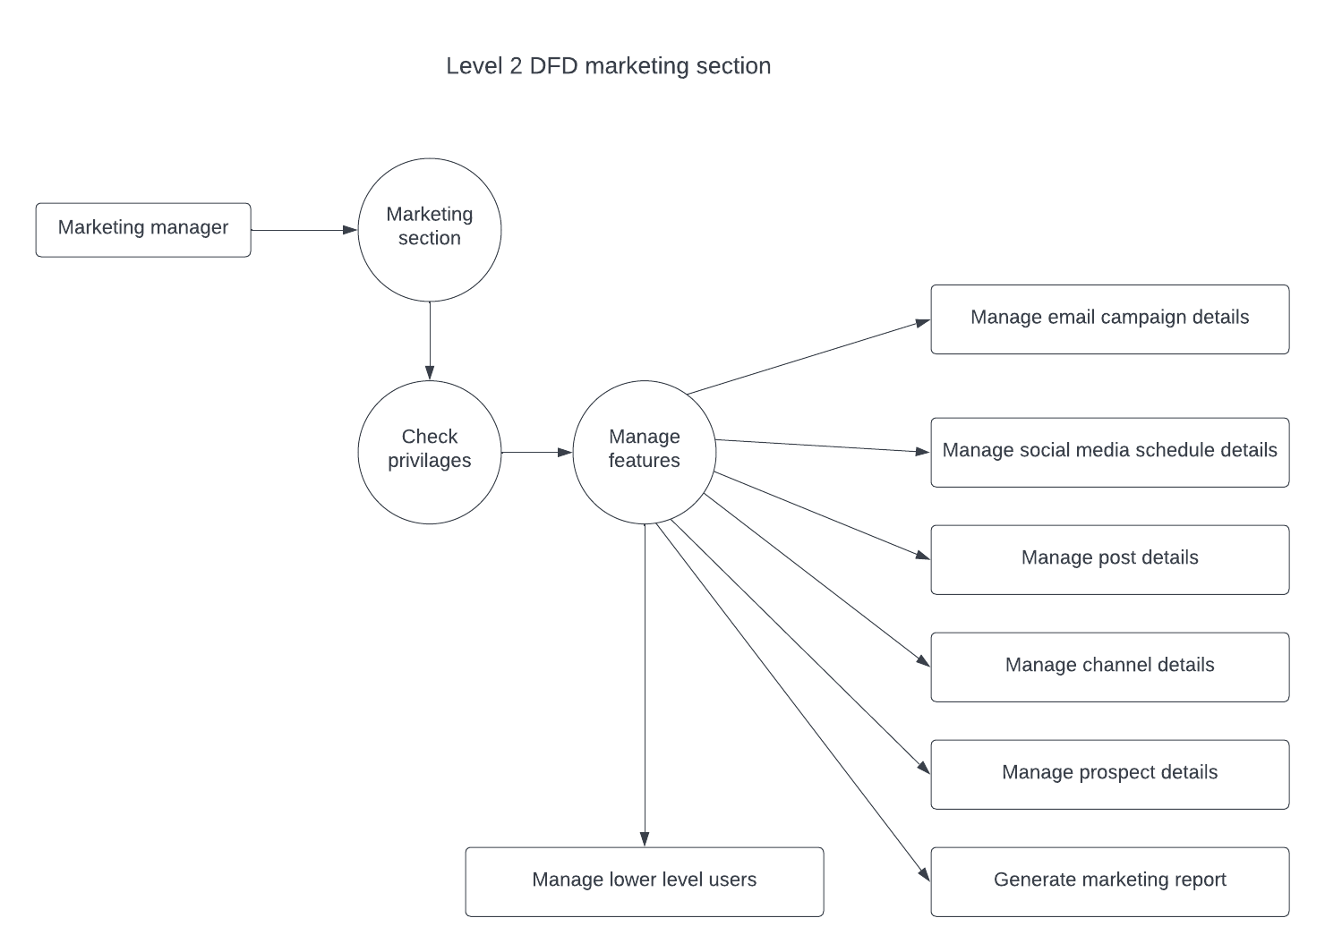

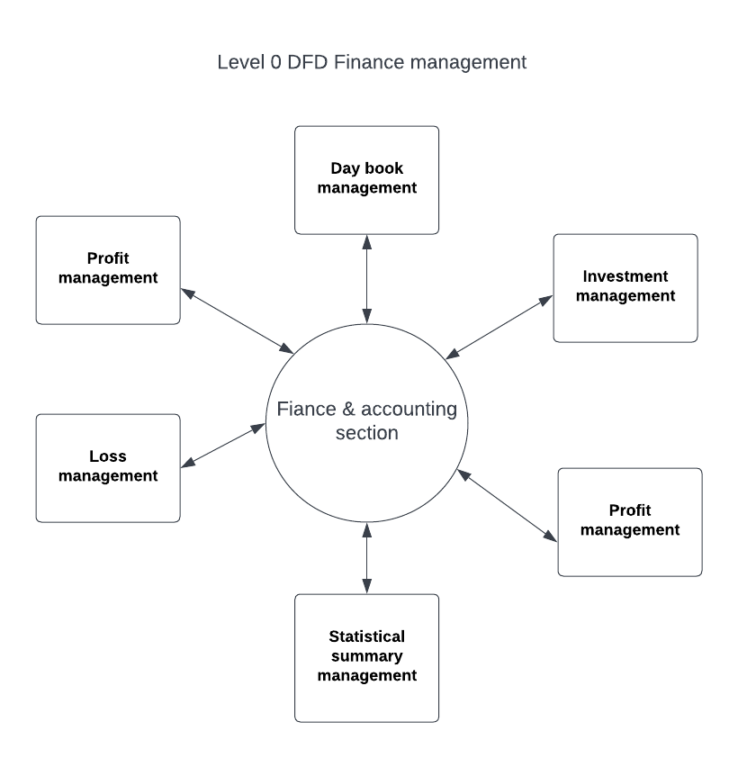Level 0 DFD finance management

Level 1 DFD finance management

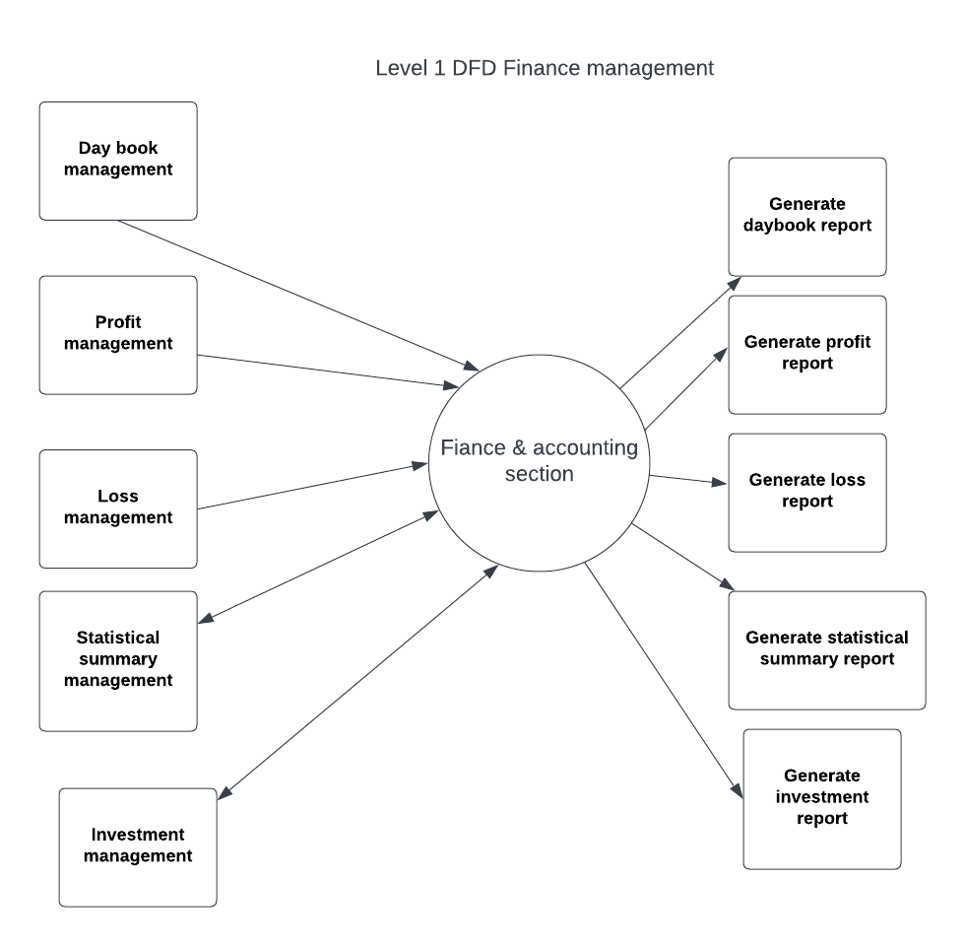

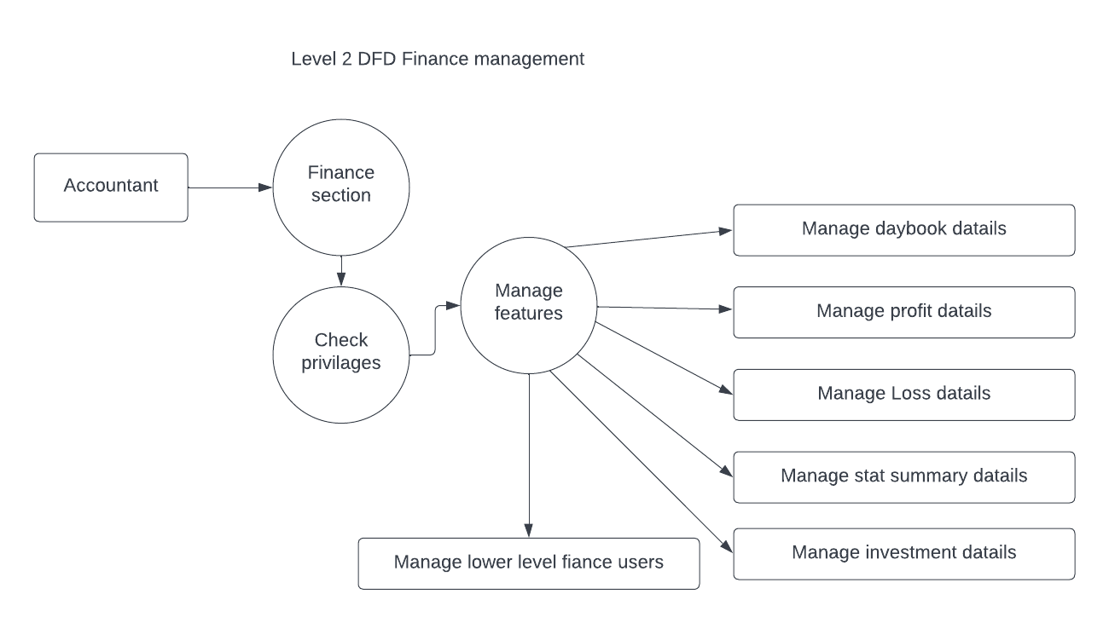Level 2 DFD finance management

Level 0 DFD human resource management

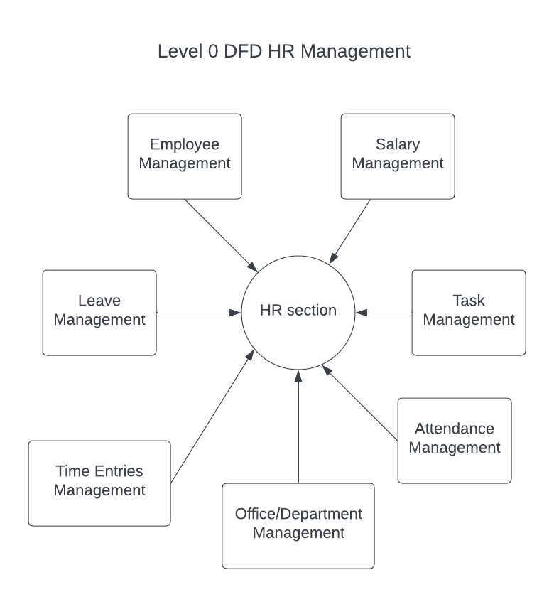

Level 1 DFD human resource management

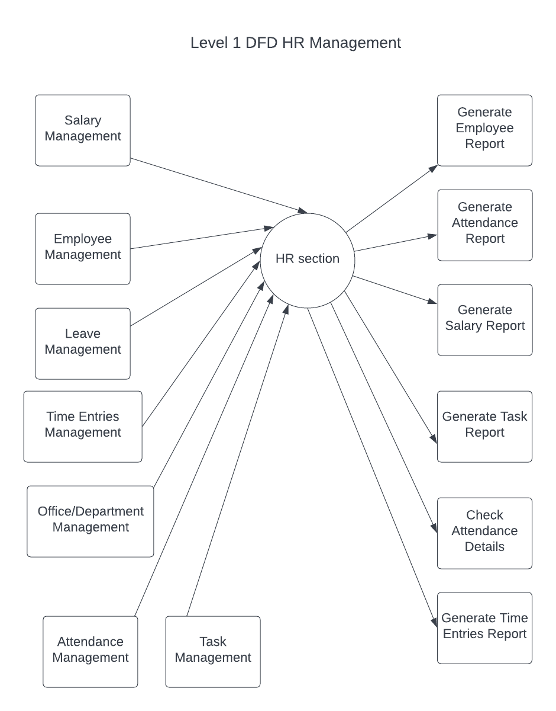

Level 2 DFD human resource management

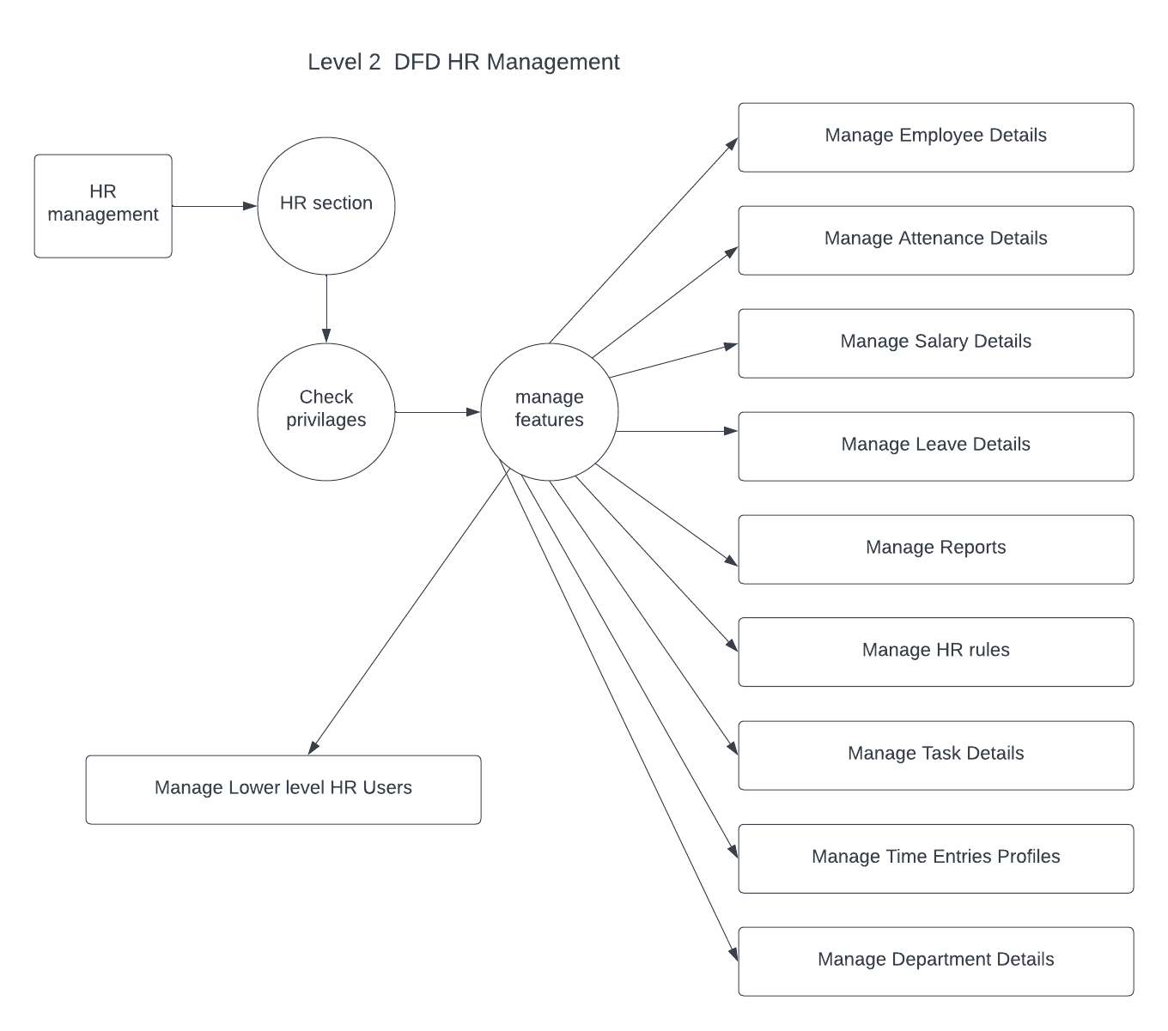

**4.13 Component diagrams**

Sales section component diagram

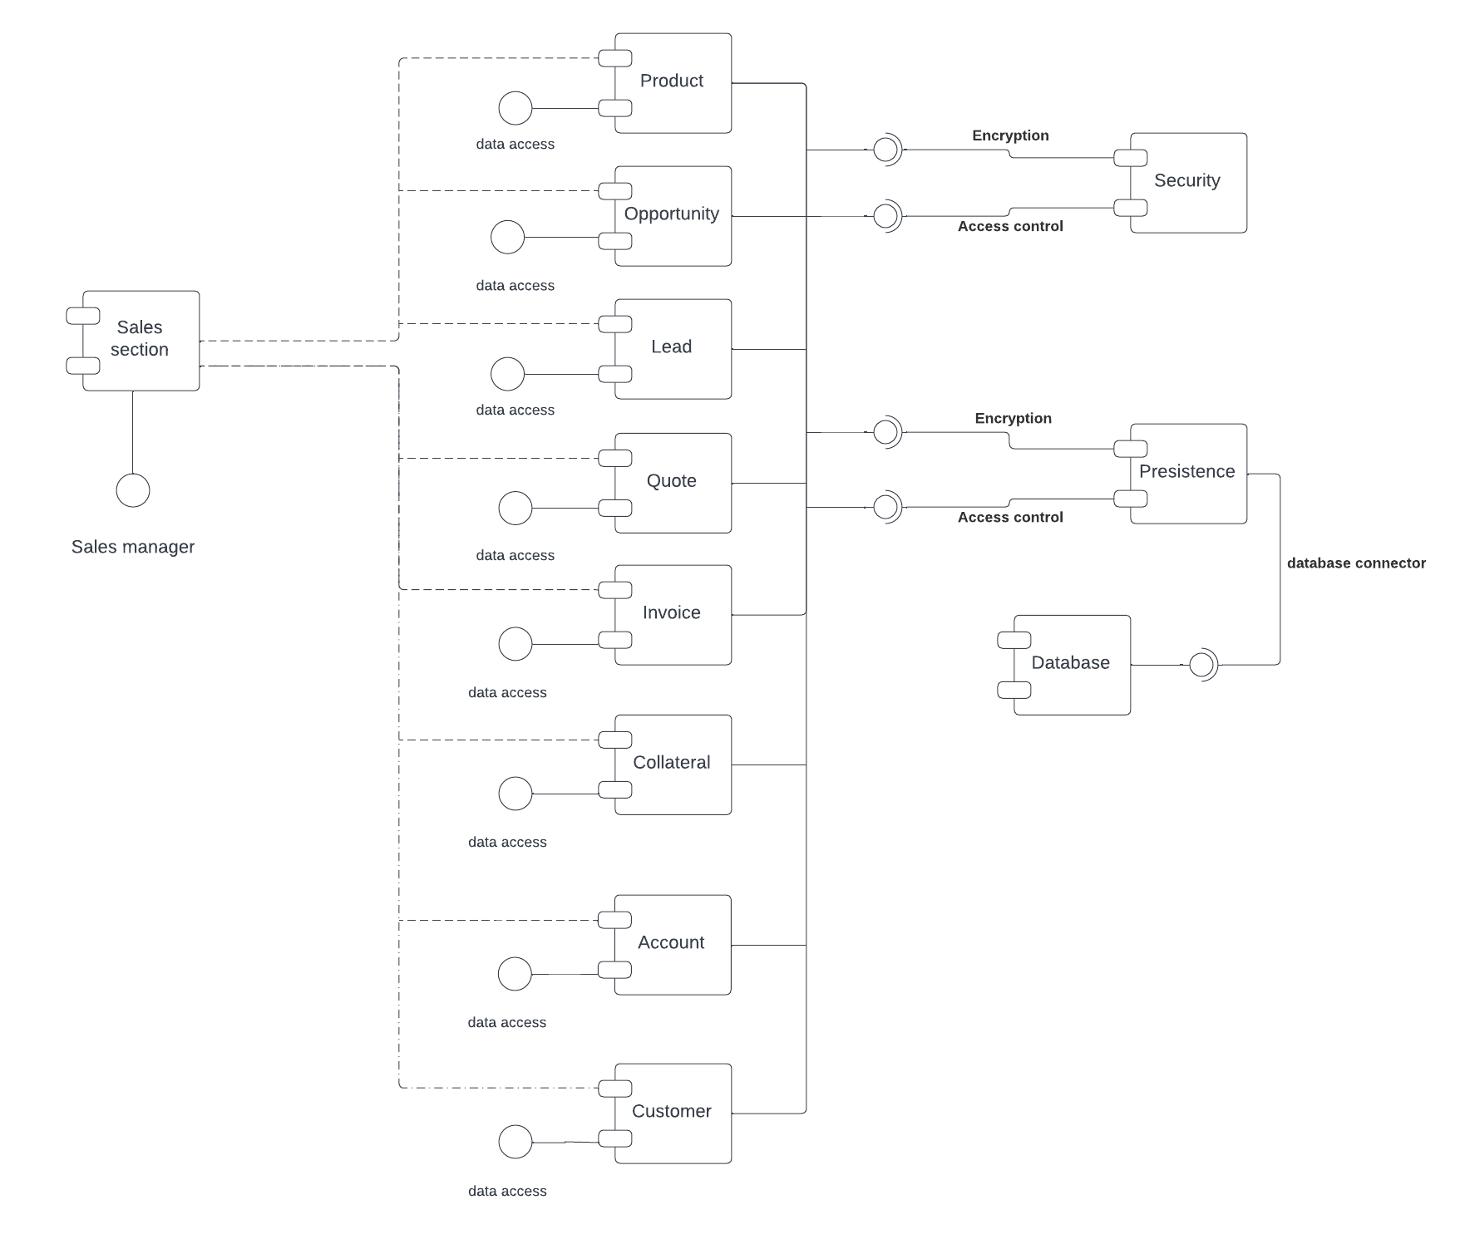

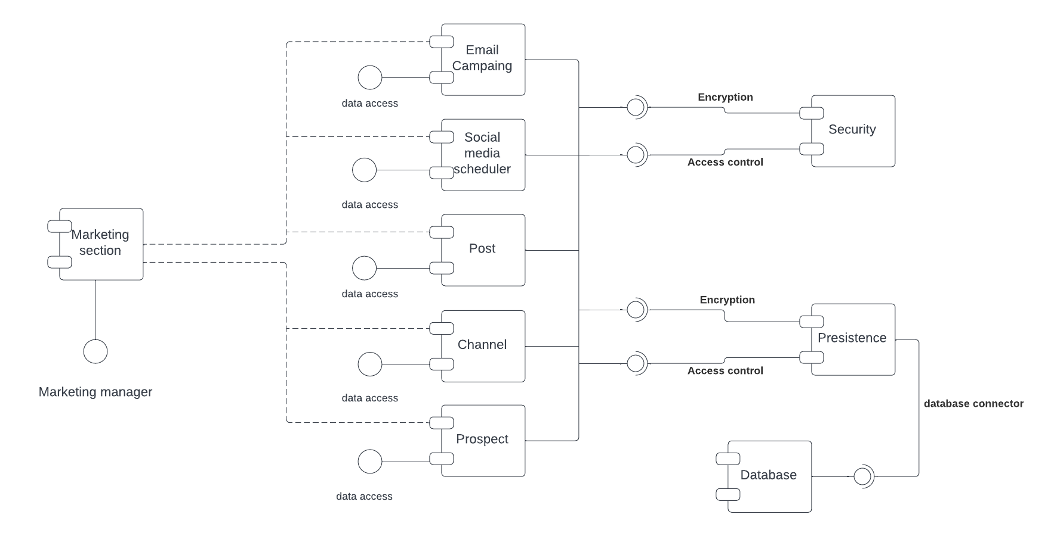Marketing section component diagram

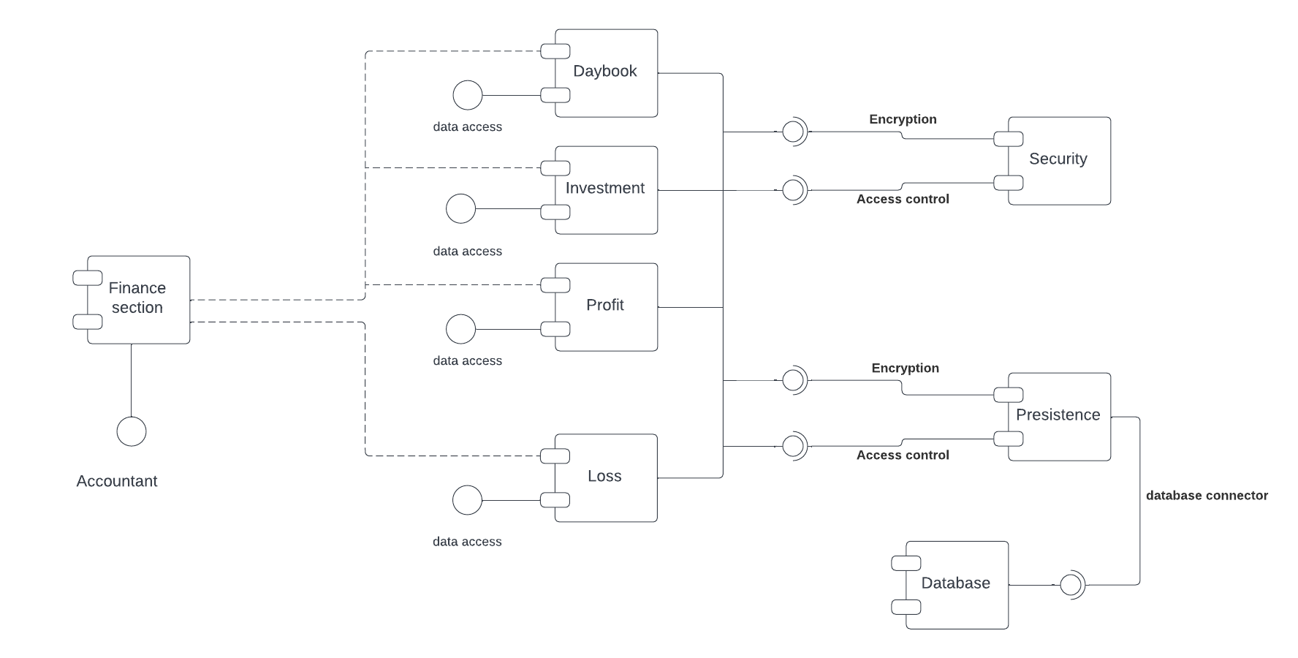Finance section component diagram

Human resource component diagram

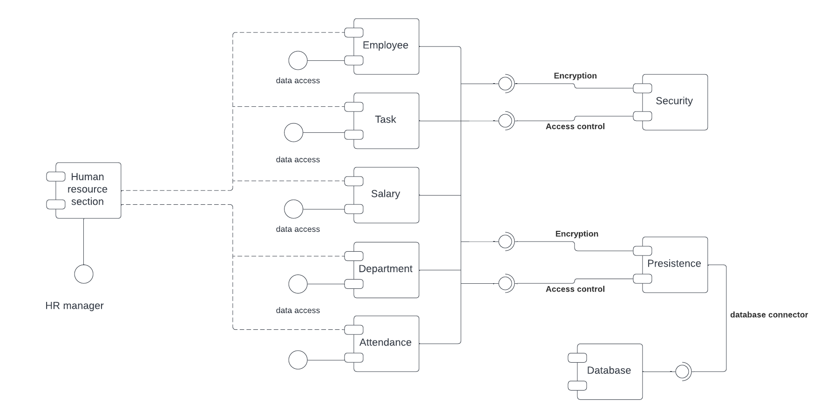

**4.14 Package diagram**

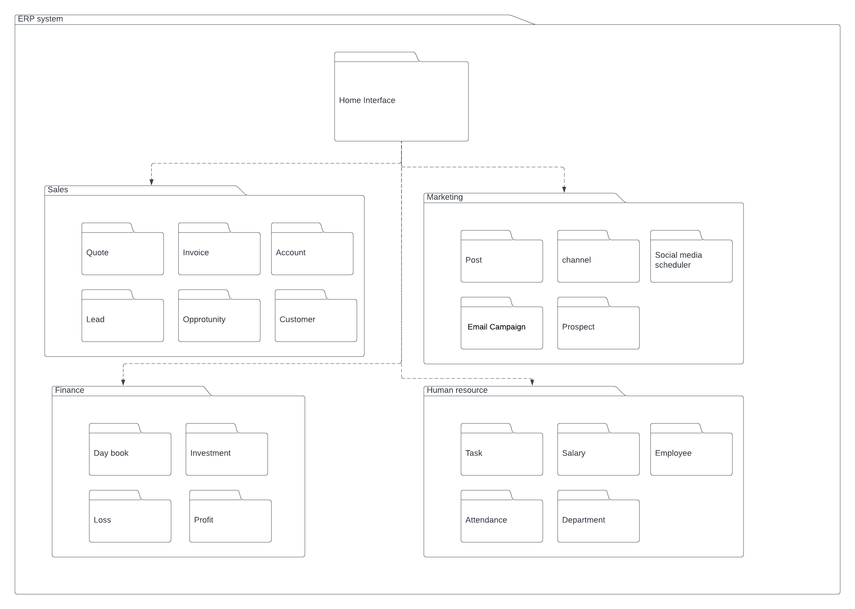

**4.15 Deployment diagram**

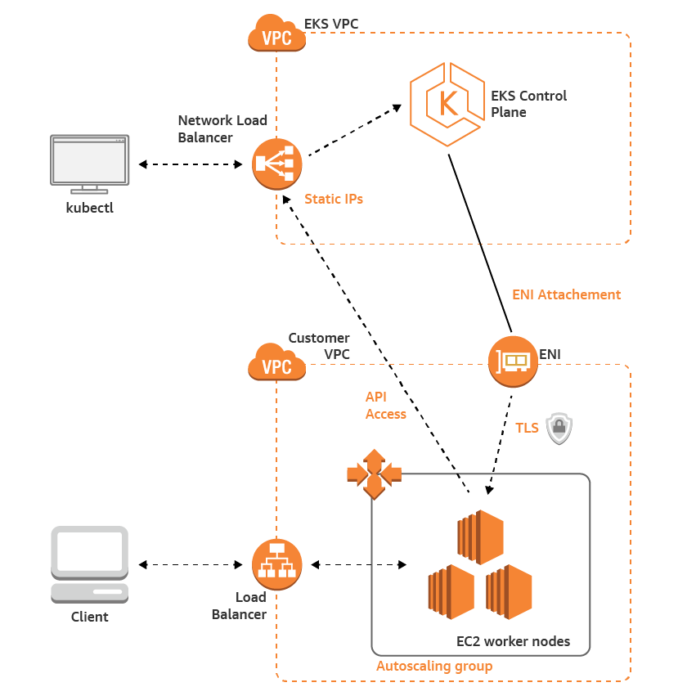

**5. Design Patterns**

Creational:

* FACTORY- By using this method pattern, the system does not create object construction calls. It hides the details of creating objects from the users and at the same time it provides an interface to generate them. The classes that implement the interface decide about the class of creating object. The users expect a secure implementation of an interface or abstract class but at the same time the specifications of the implementation are not very important. When we designed the system, we took in consideration that it needs the objectives factory so if a product that has many classes with similar base class, we can manipulate the objects through the interface or abstract class.

ABSTRACT FACTORY- By using this method we move a to a higher level of abstraction. The user in this case has no knowledge of in the kind of the factory that is being used. The system provides and interface for creating groups of depended on objects, which are being used by the user.

**User**

OBSERVER PATTERN- By using this pattern the system can inform the group of objects that another object related to the previous ones has changed its state. This is used in the “quote to invoice part” where an opportunity should know if there is a change in the state of the object

**Quote**

**Invoice**

Structural:

ADAPTER-By using this pattern the system is introducing to the client a new interface that hides the previous one. Due to the adaptation the communication between the classes in now possible due to the compatible interface

**User**

**Customer**

**Adapter**

**Account**

